**B.Nikhil**

**192111054**

**OBJECT ORIENTED ANALYSIS AND DESIGN FOR SOFTWARE DESIGN(CSA1176)**

LAB DAY-01

**1.Passport Management System**

**Use case Diagram**

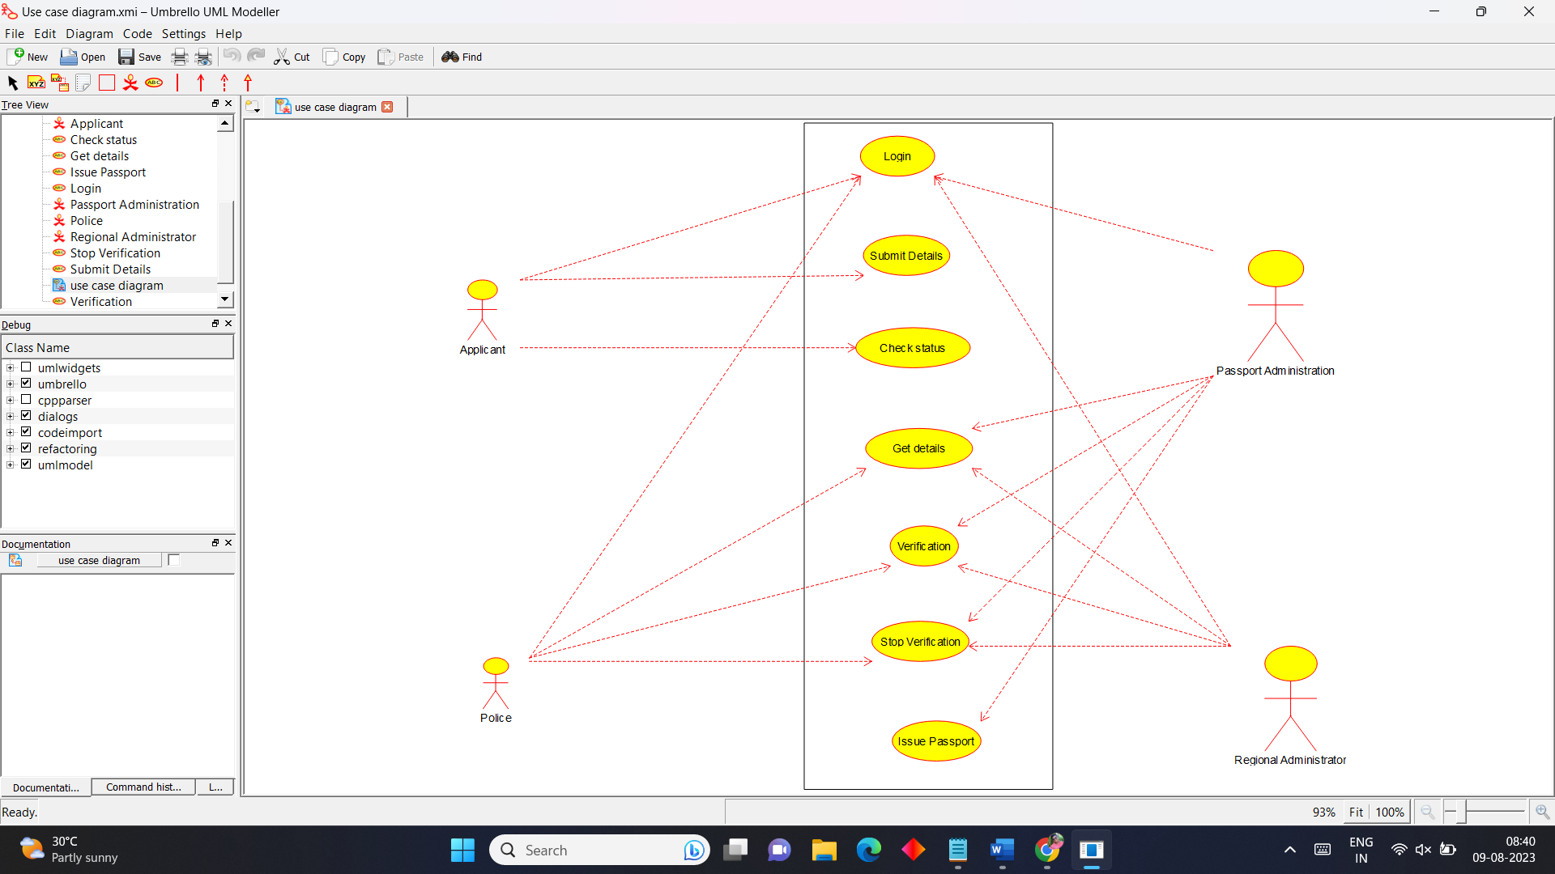

**Class Diagram**

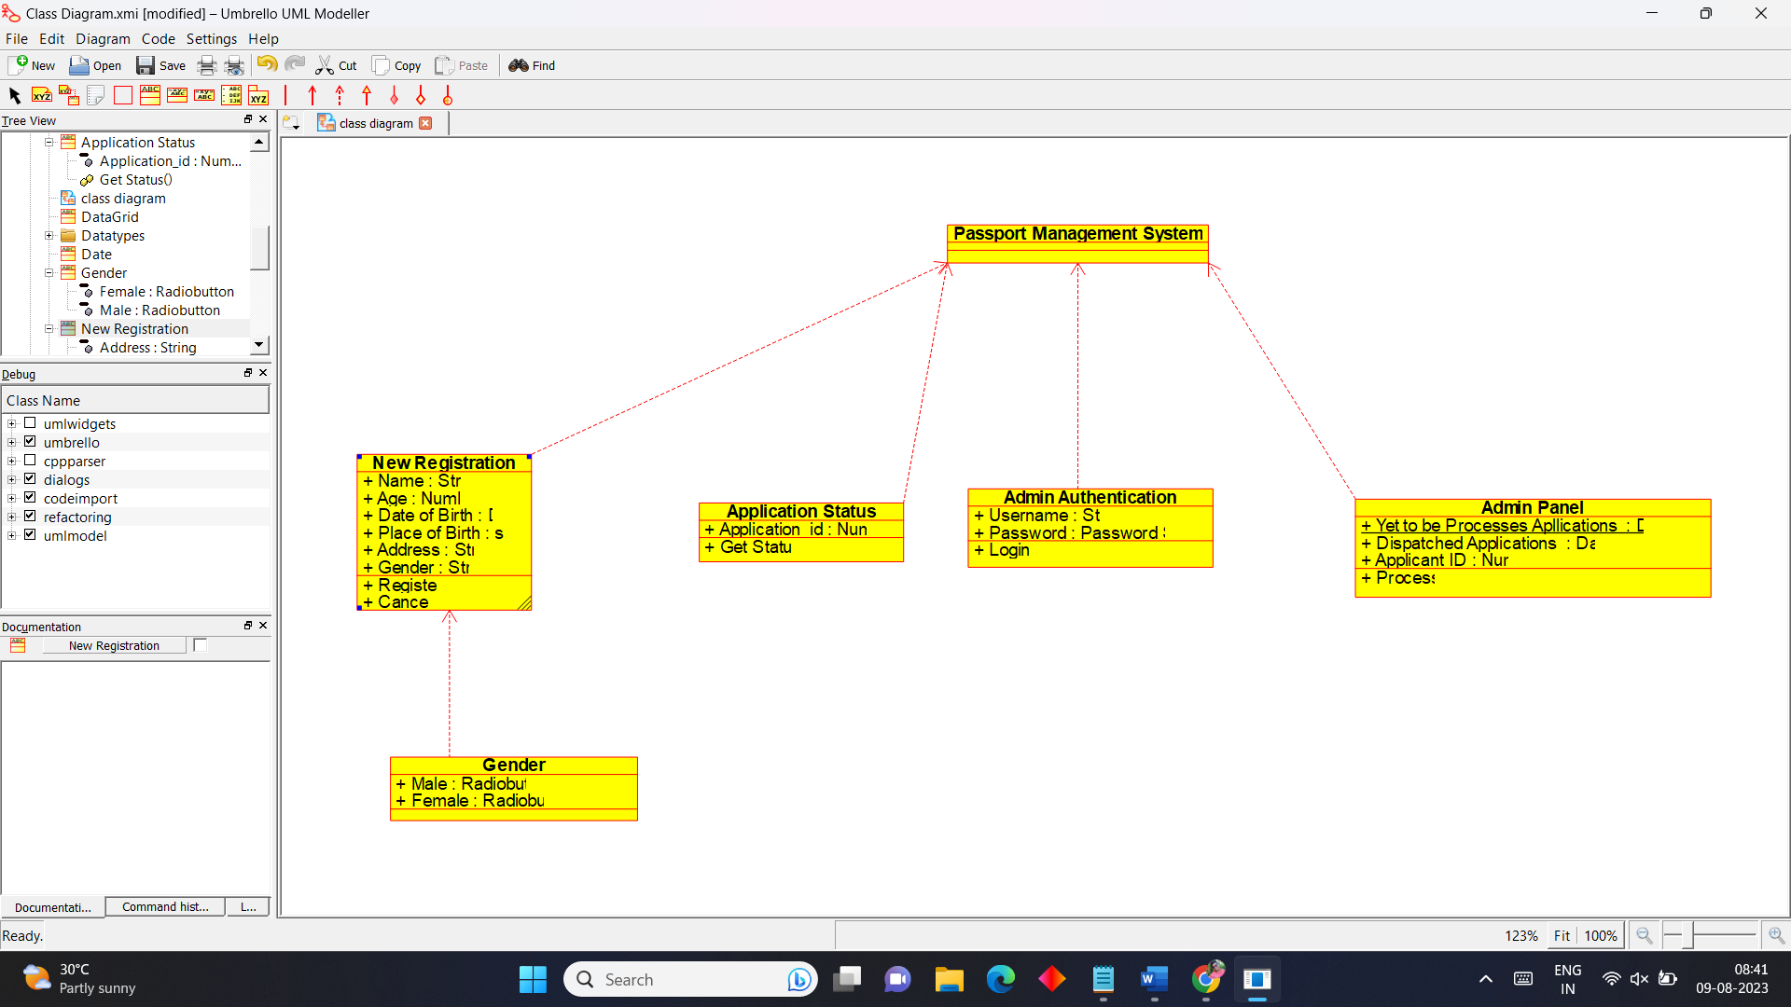

**Activity Diagram**

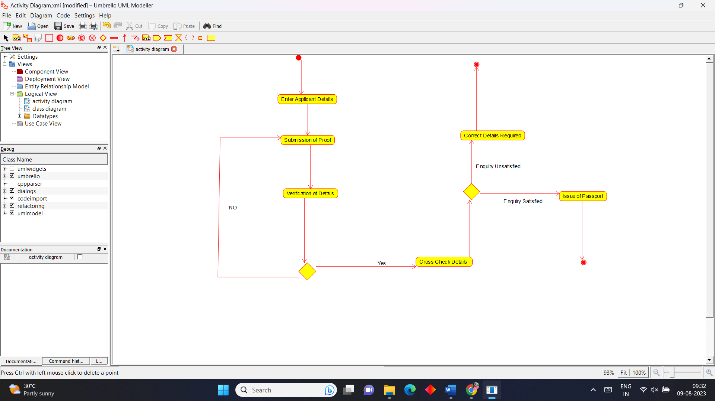

**State Chart Diagram**

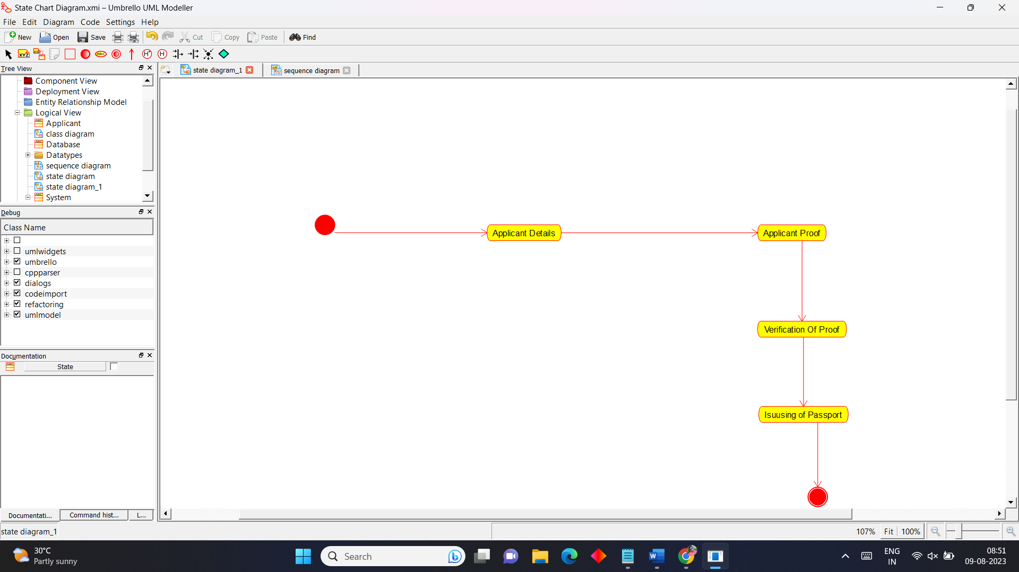

**Sequence Diagram**

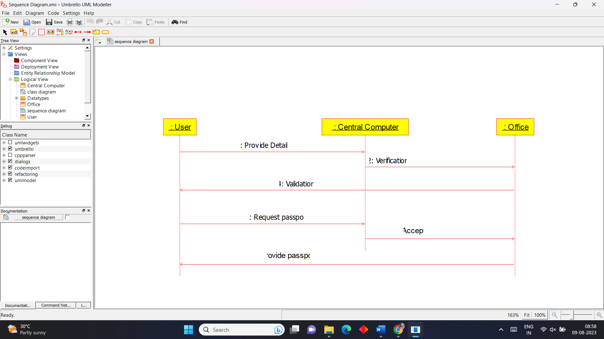

**2.Book Bank Process**

**Use Case Diagram**

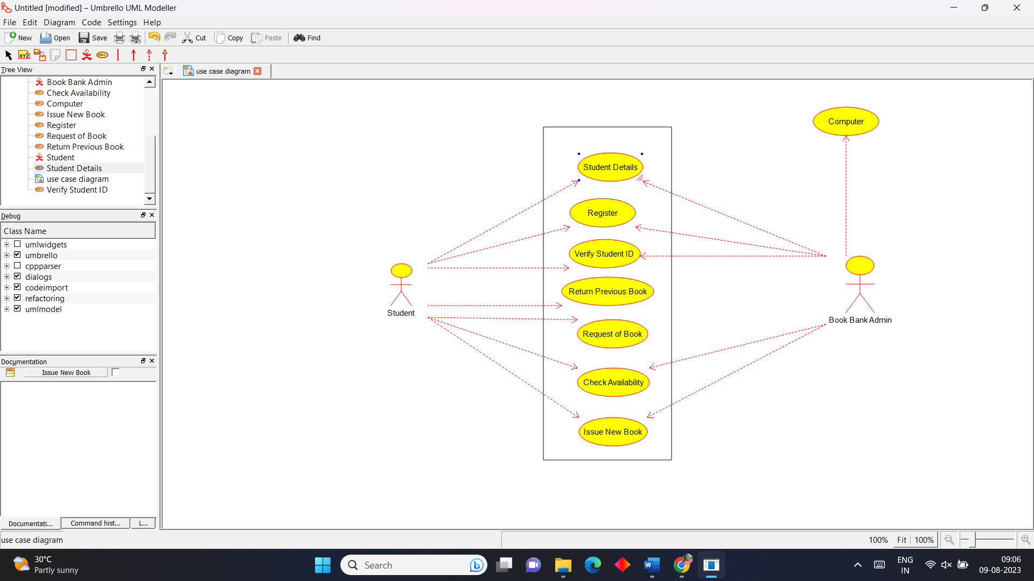

**Class Diagram**

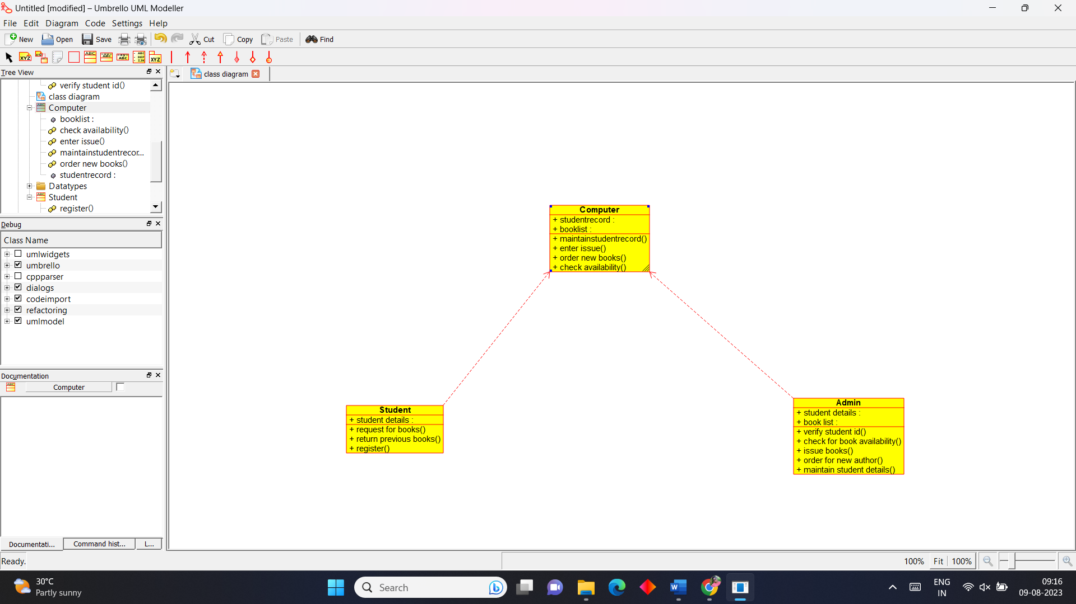

**Activity Diagram**

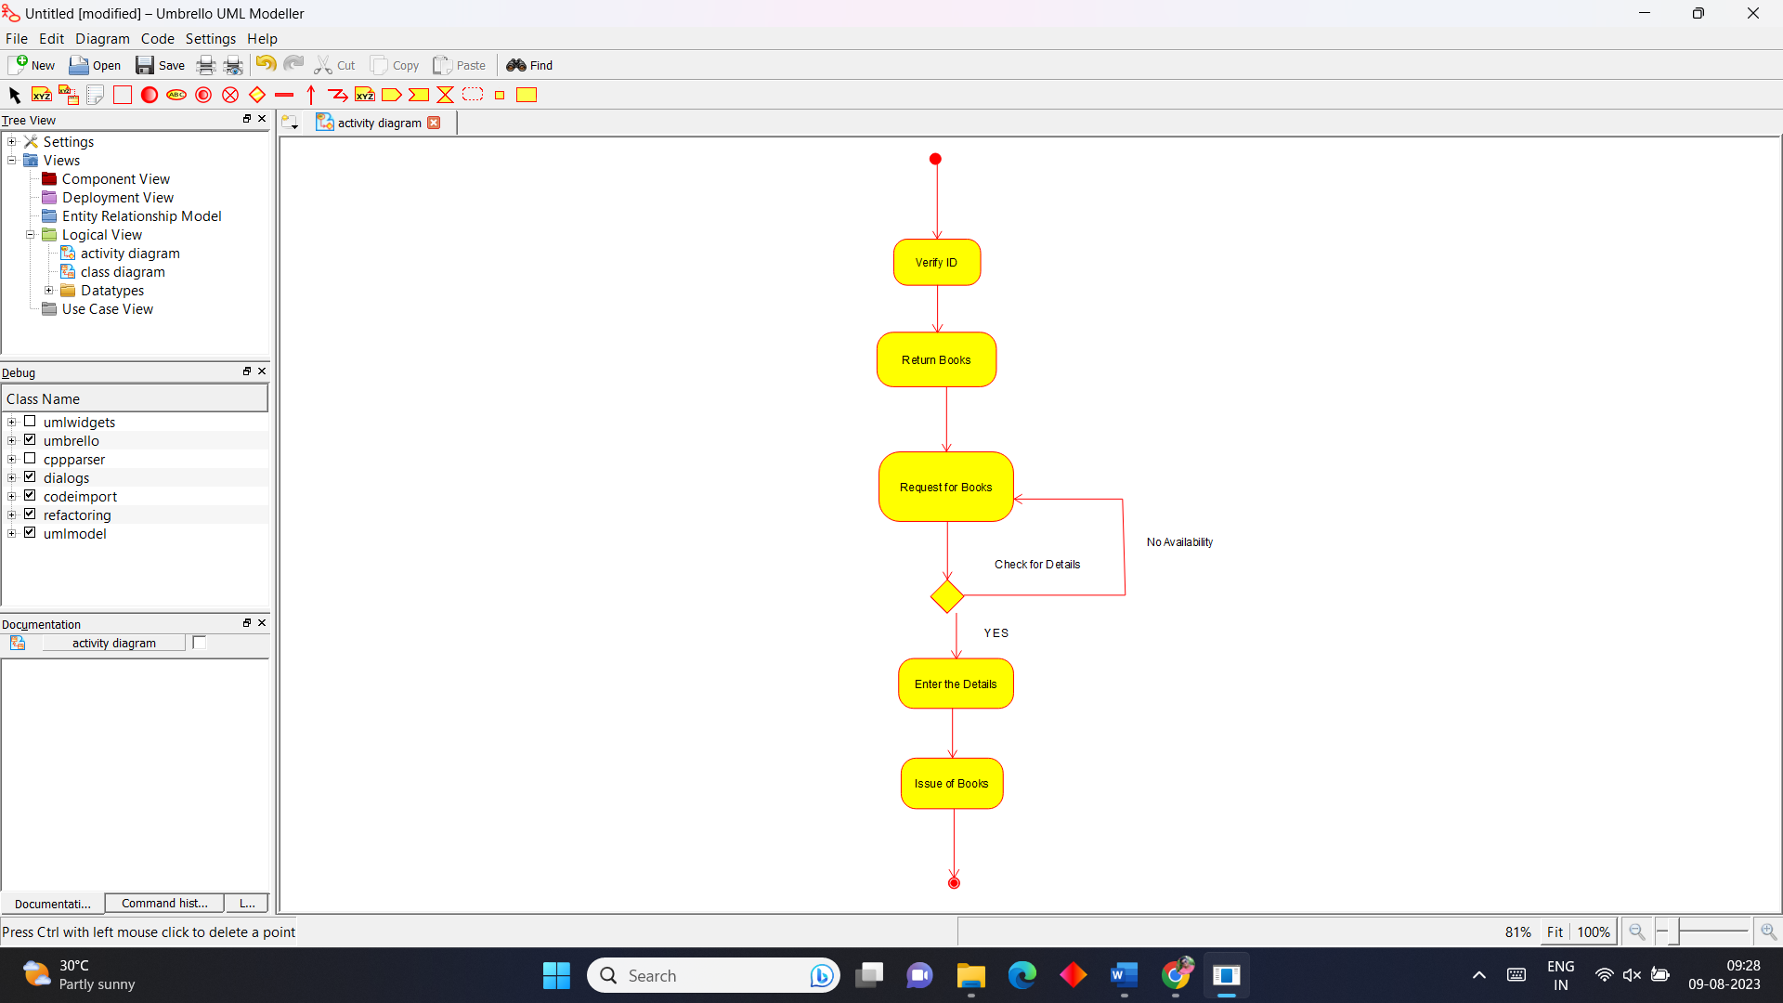

**State Chart Diagram**

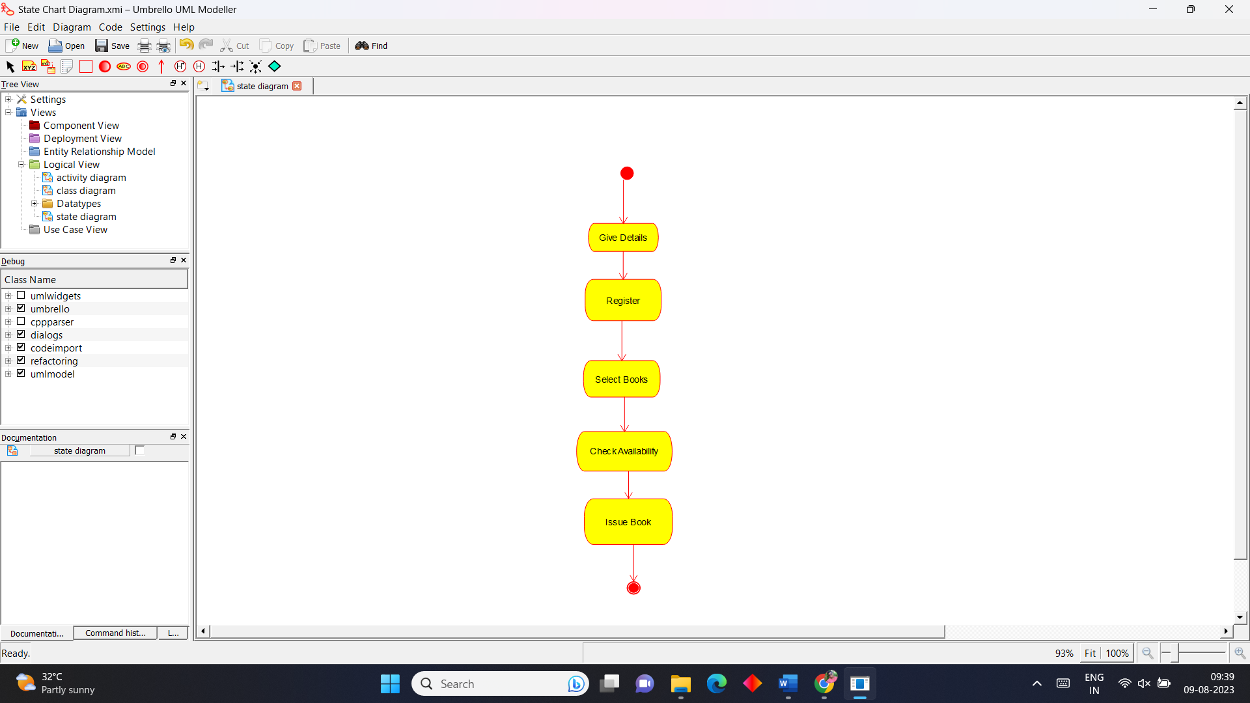

**Sequence Diagram**

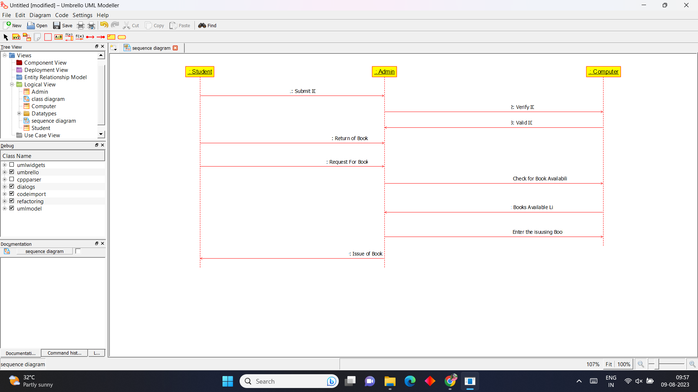

**3.Exam Registration Portal**

**Use Case Diagram**

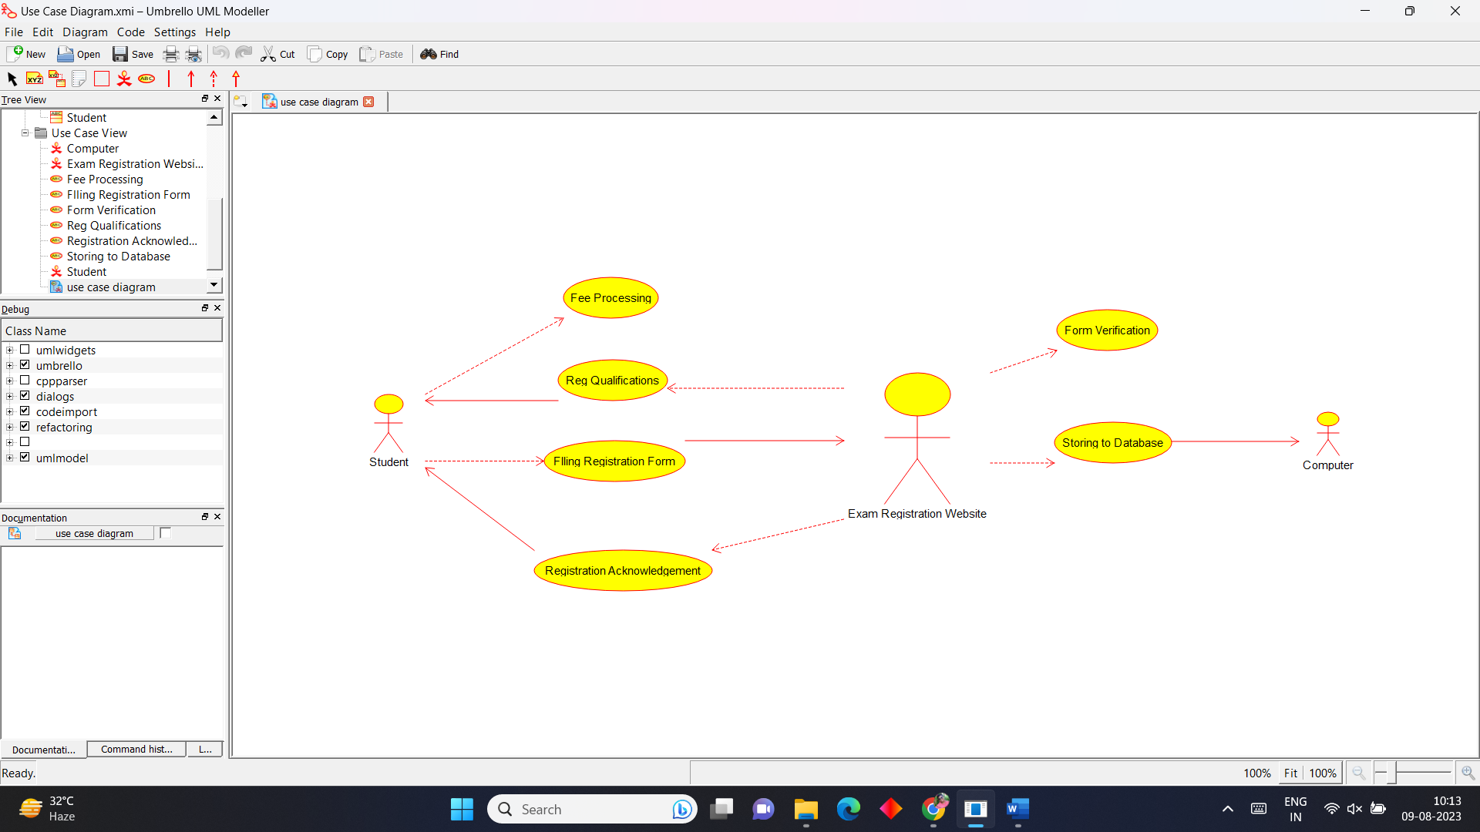

**Class Diagram**

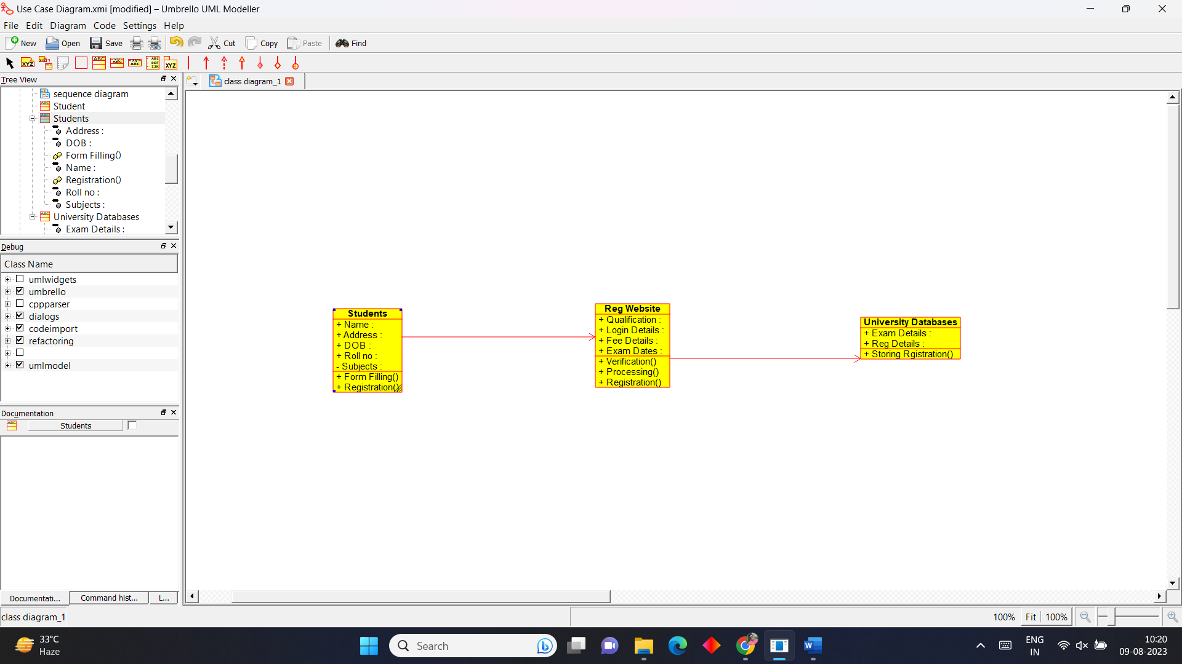

**Activity Diagram**

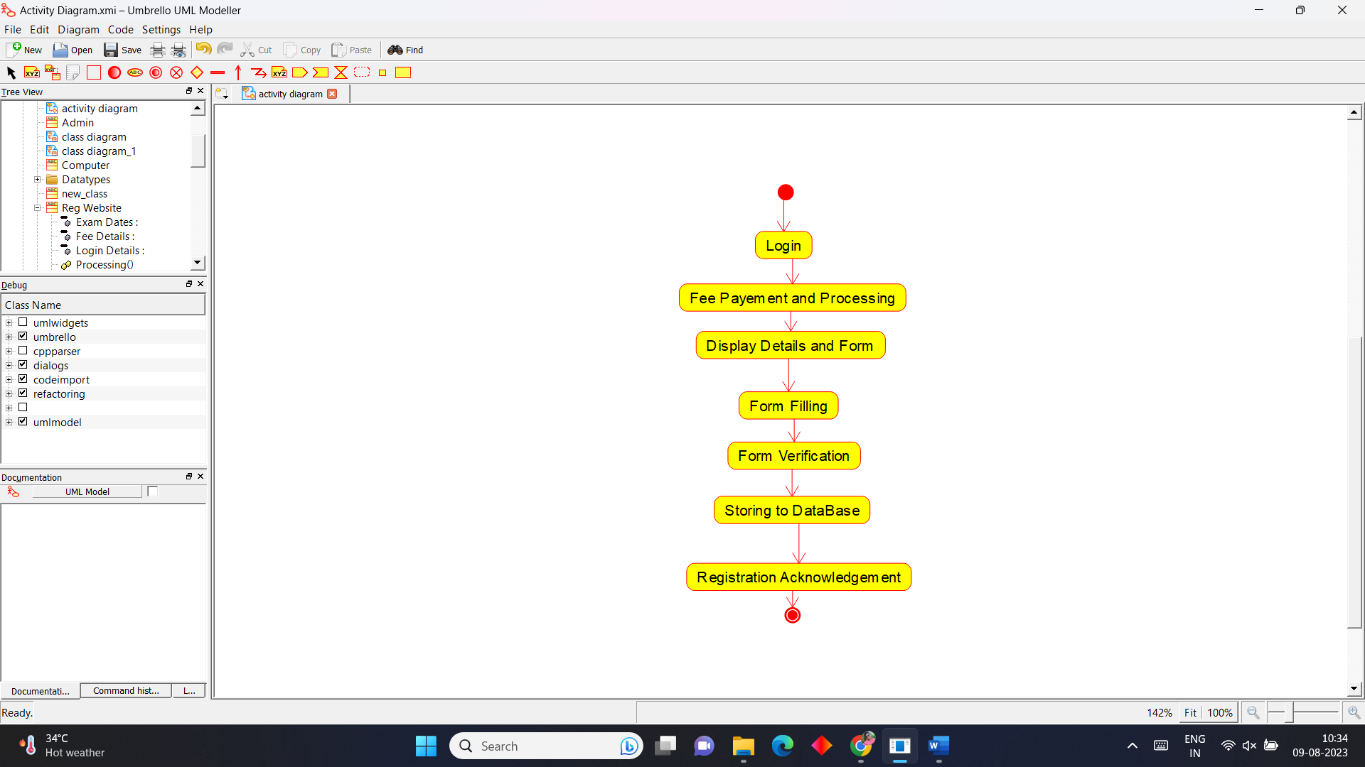

**State Chart Diagram**

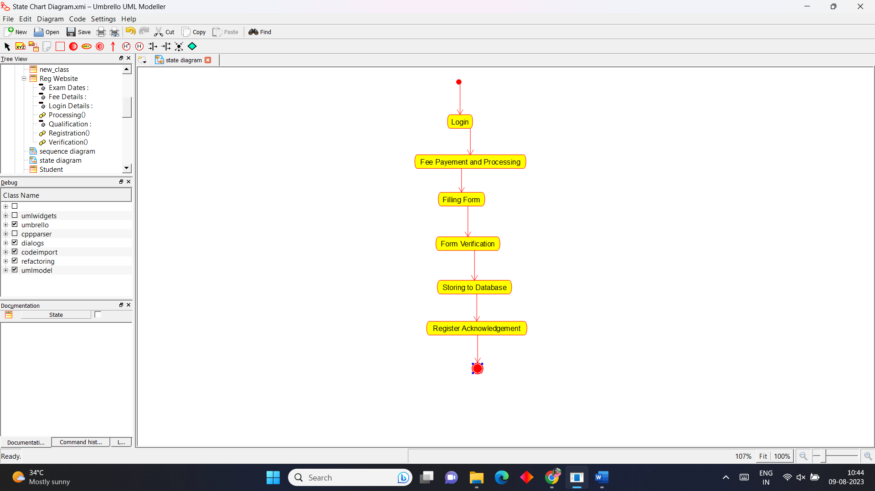

**Sequence Diagram**

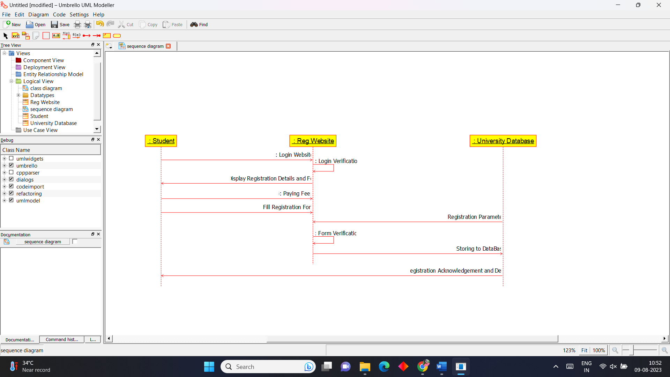

**4.Stock Maintenance system**

**Use Case Diagram**

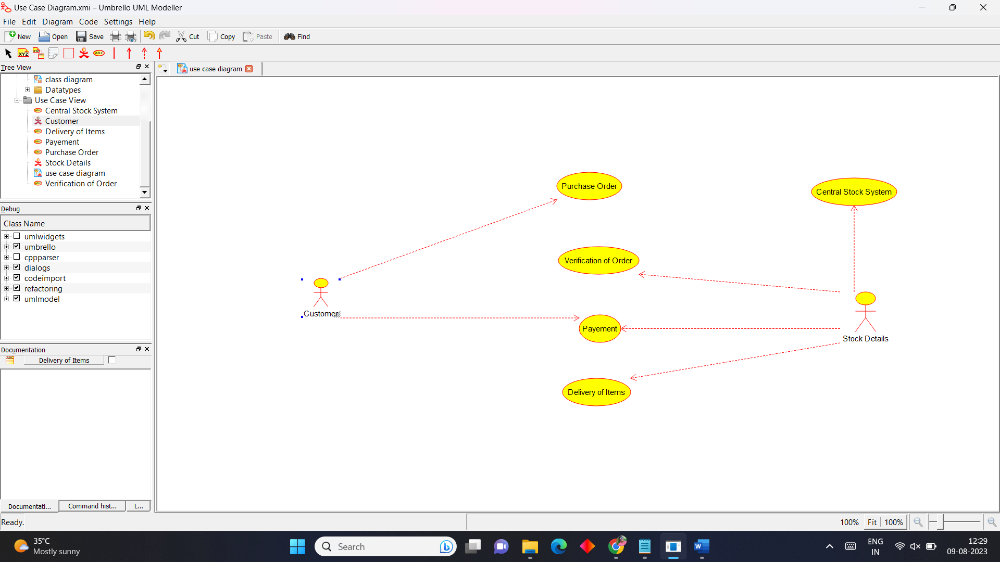

**Class Diagram**

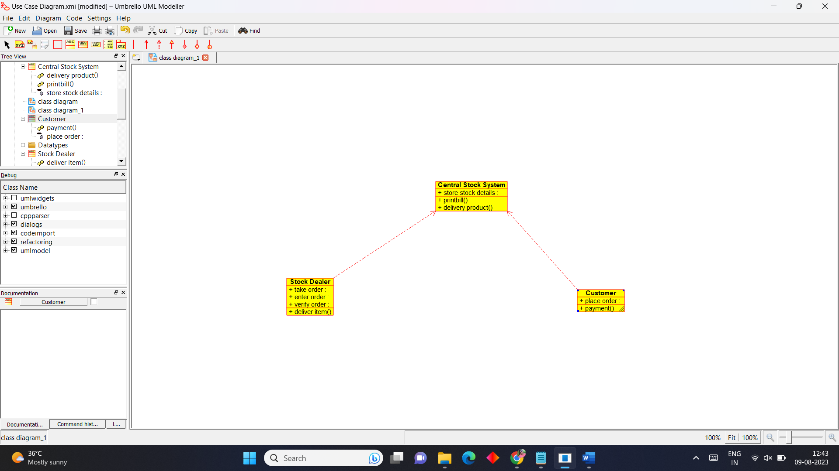

**Activity Diagram**

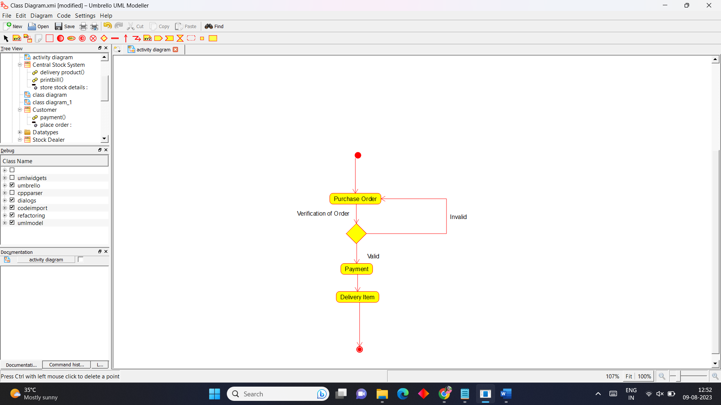

**State Chart Diagram**

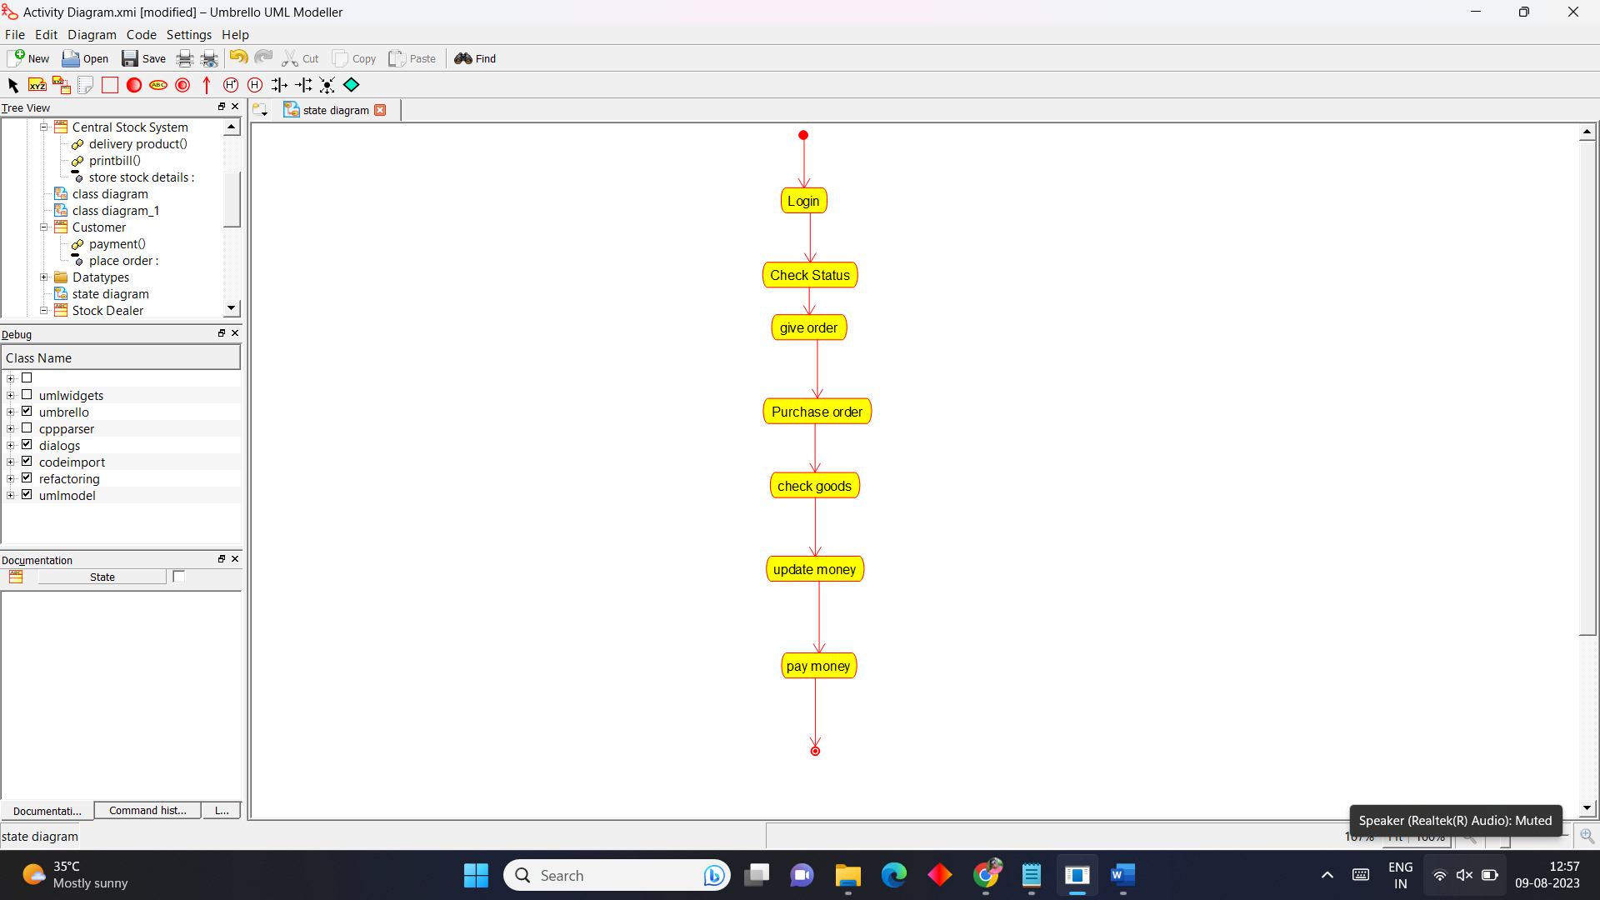

**Sequence Diagram**

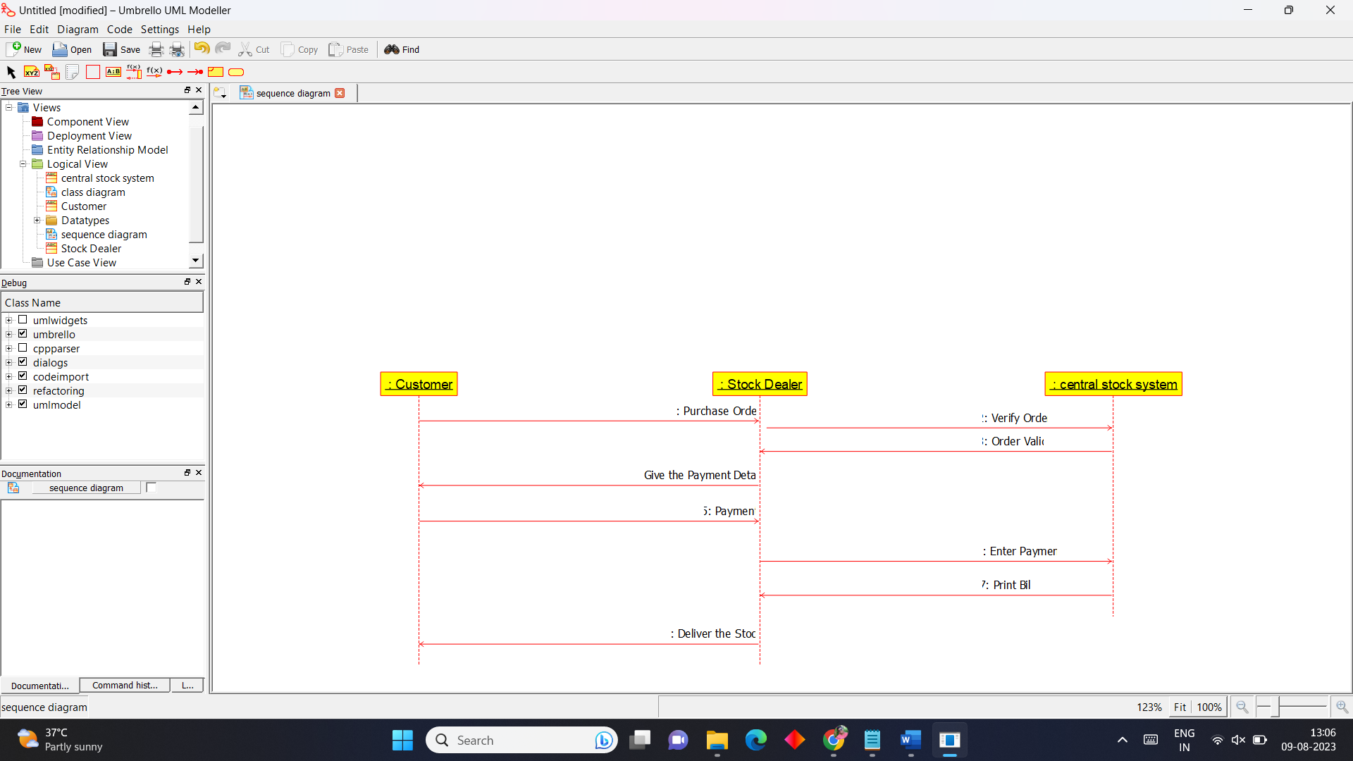

**5.Online Course Reservation System**

**Use Case Diagram**

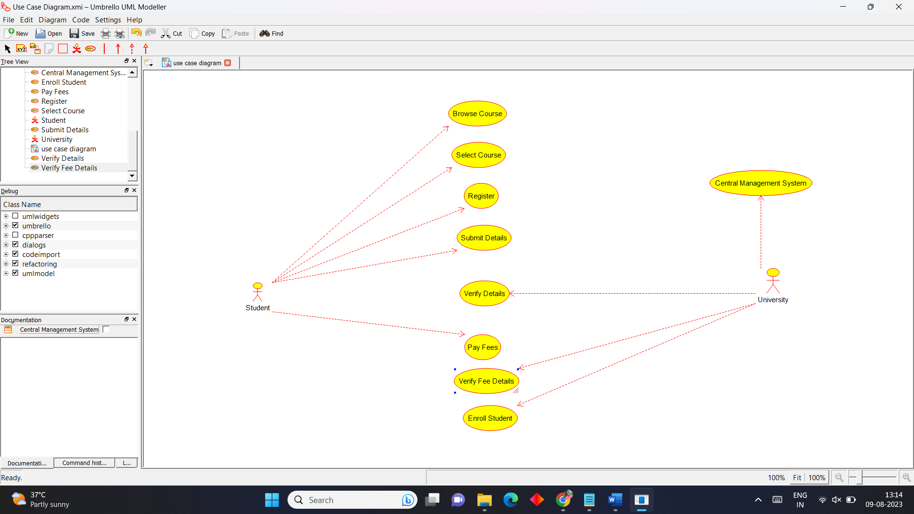

**Class Diagram**

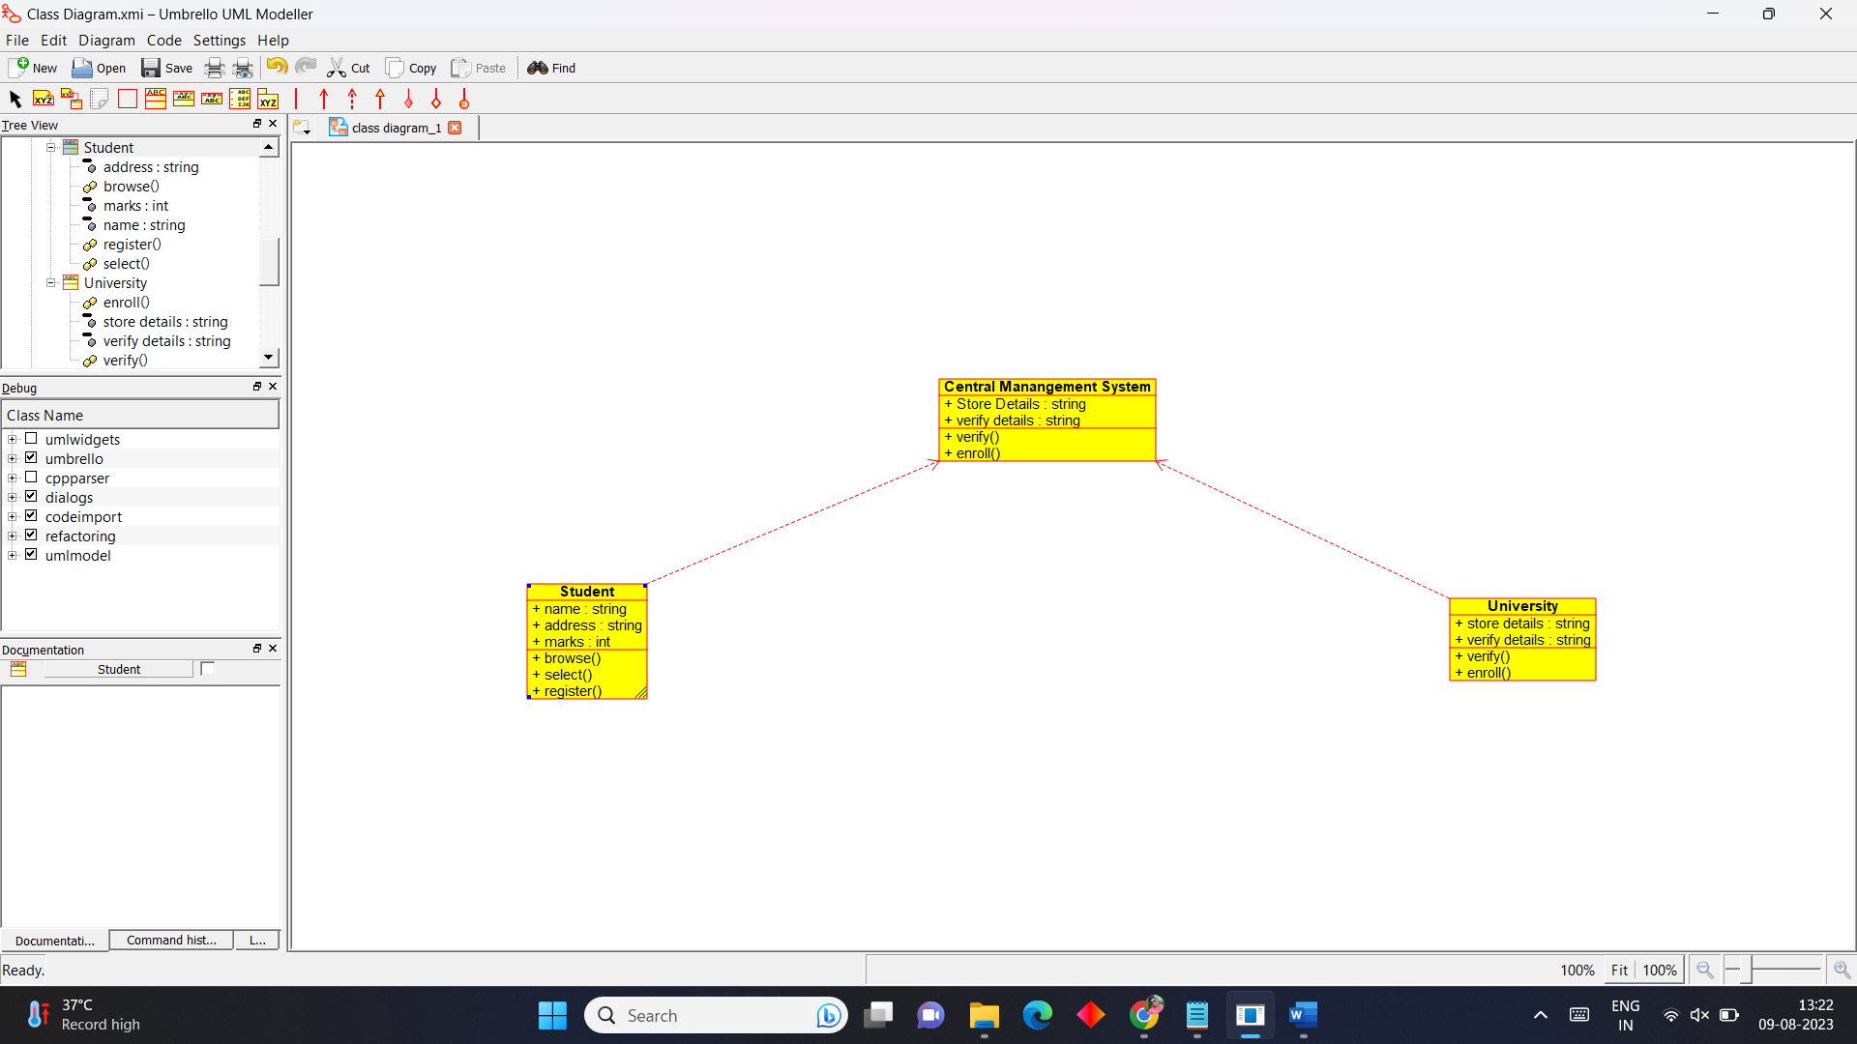

**Activity Diagram**

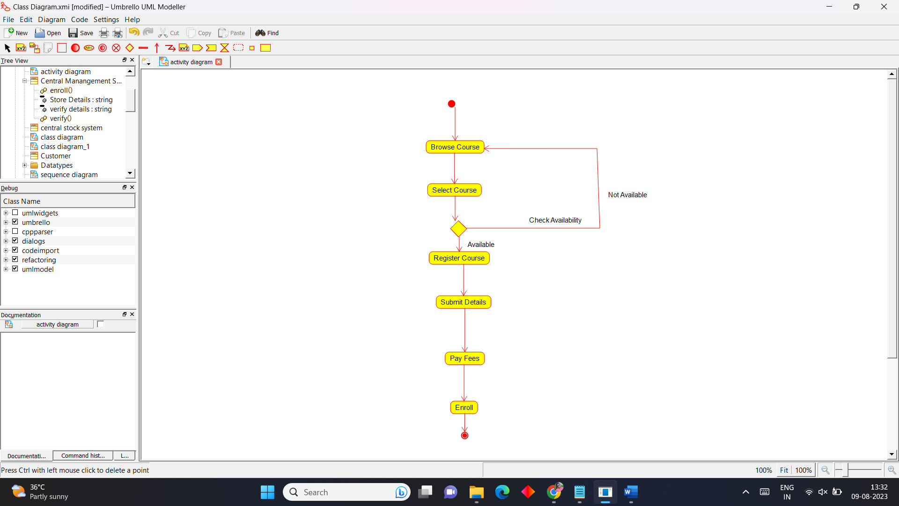

**State Chart Diagram**

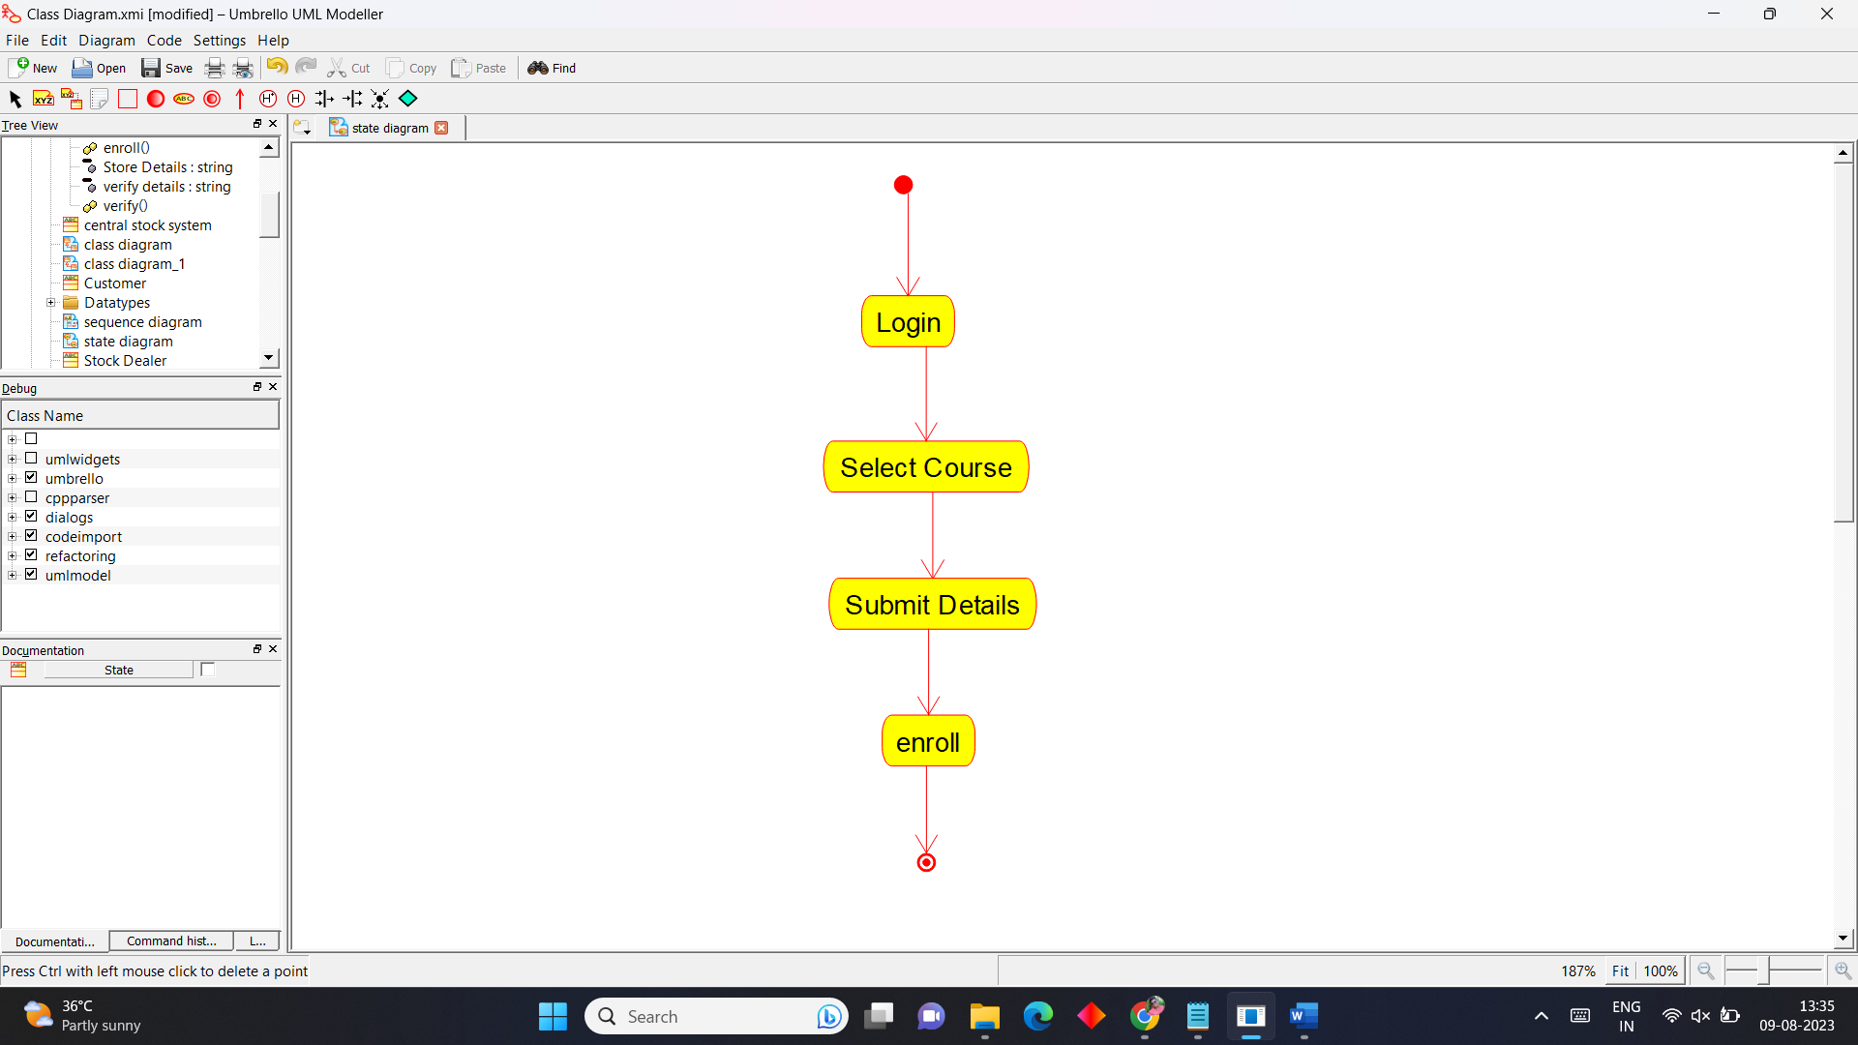

**Sequence Diagram**

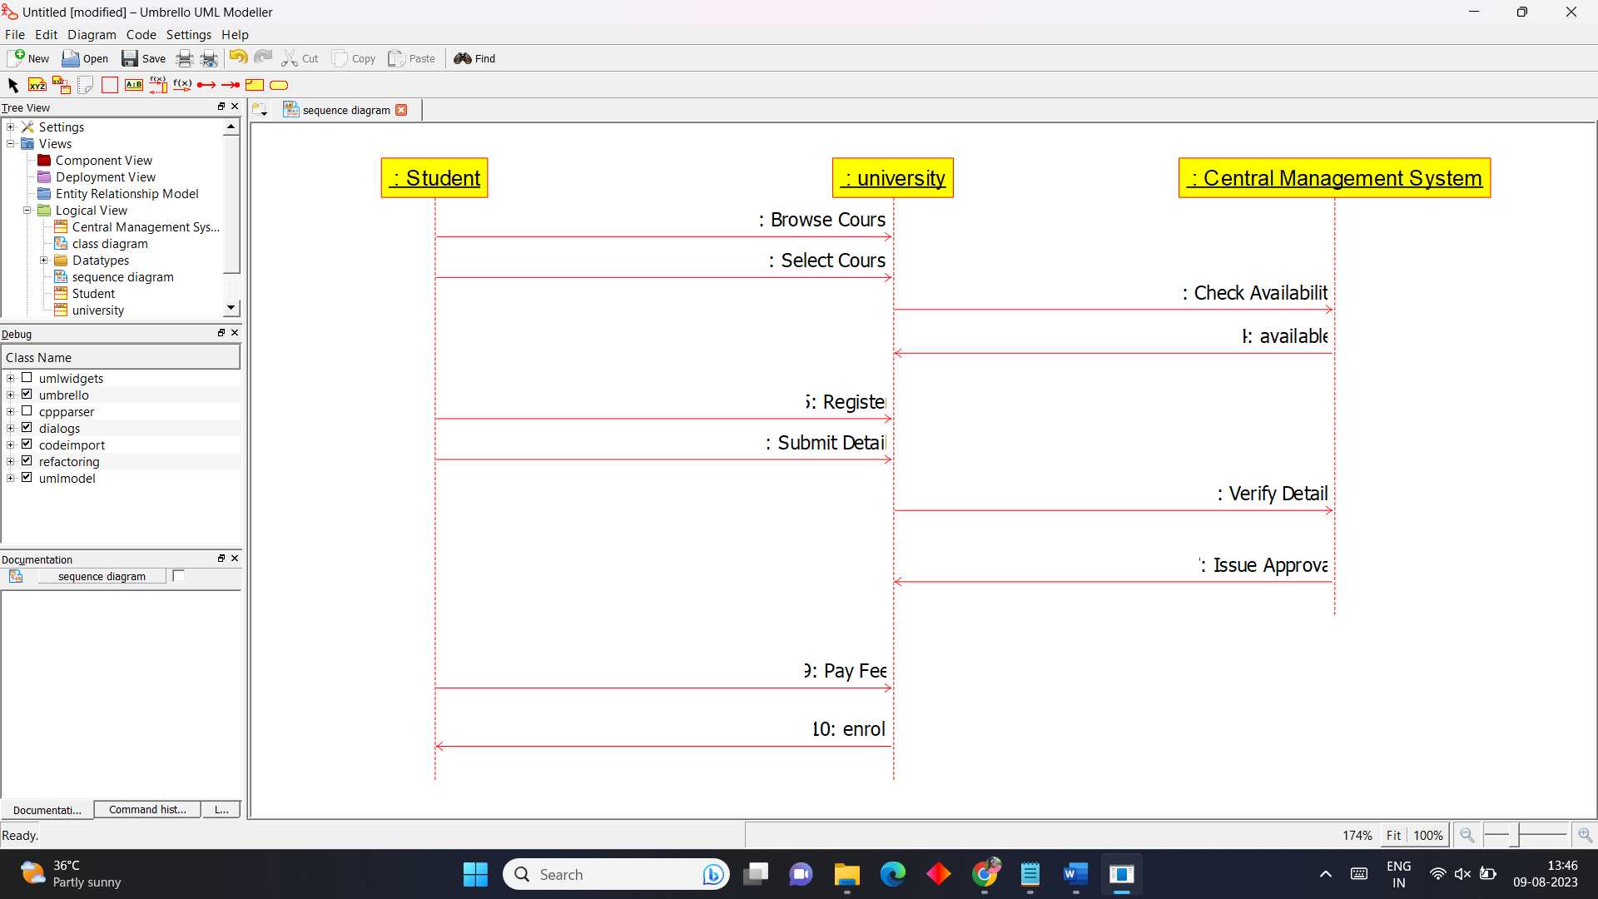

**6.E-Ticketing System**

**Use Case Diagram**

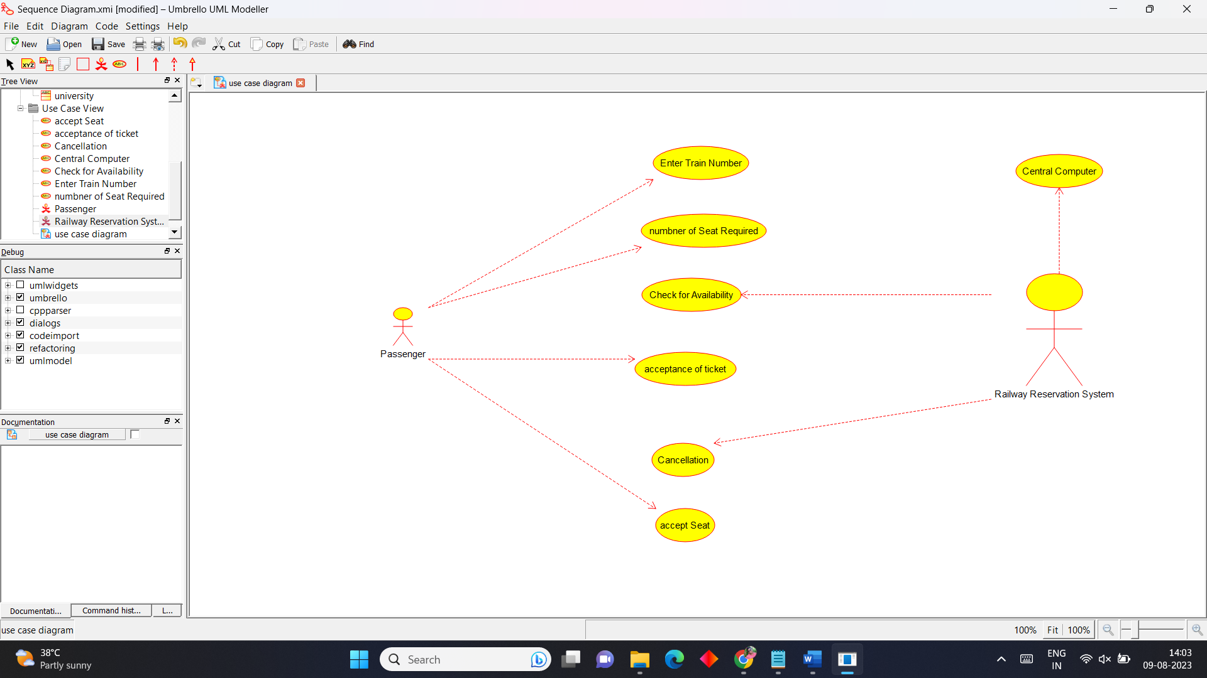

**Class Diagram**

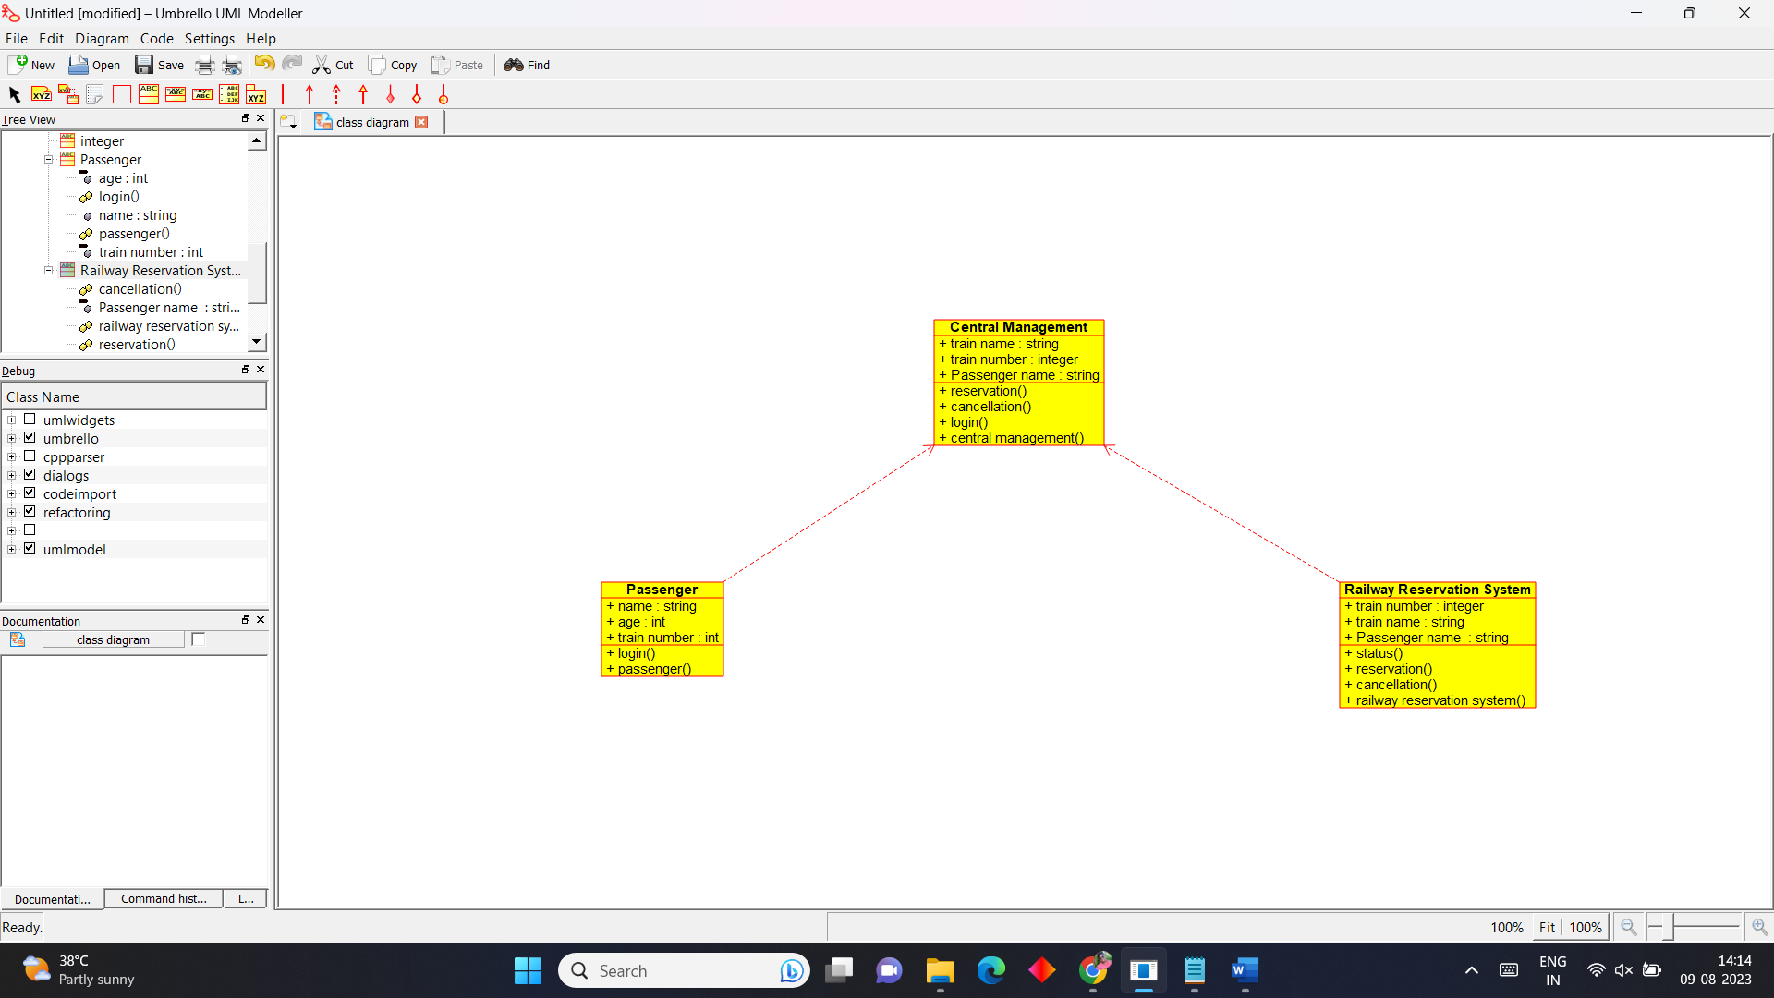

**Activity Diagram**

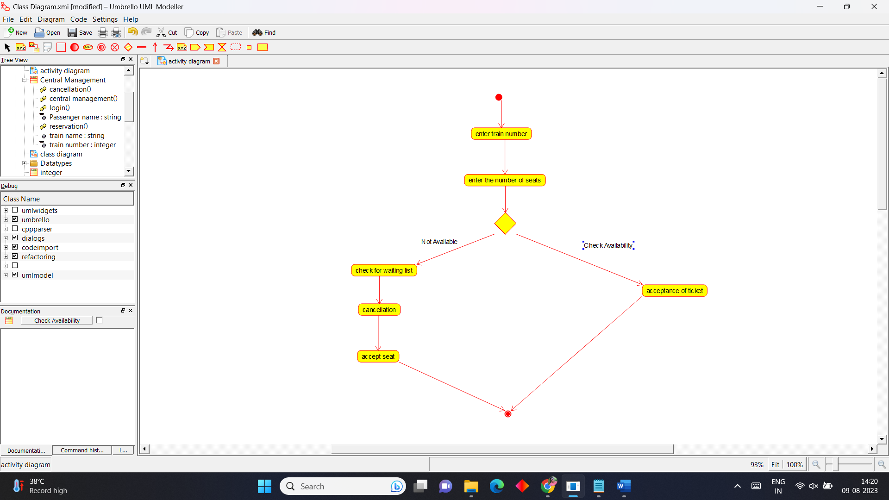

**State Chart Diagram**

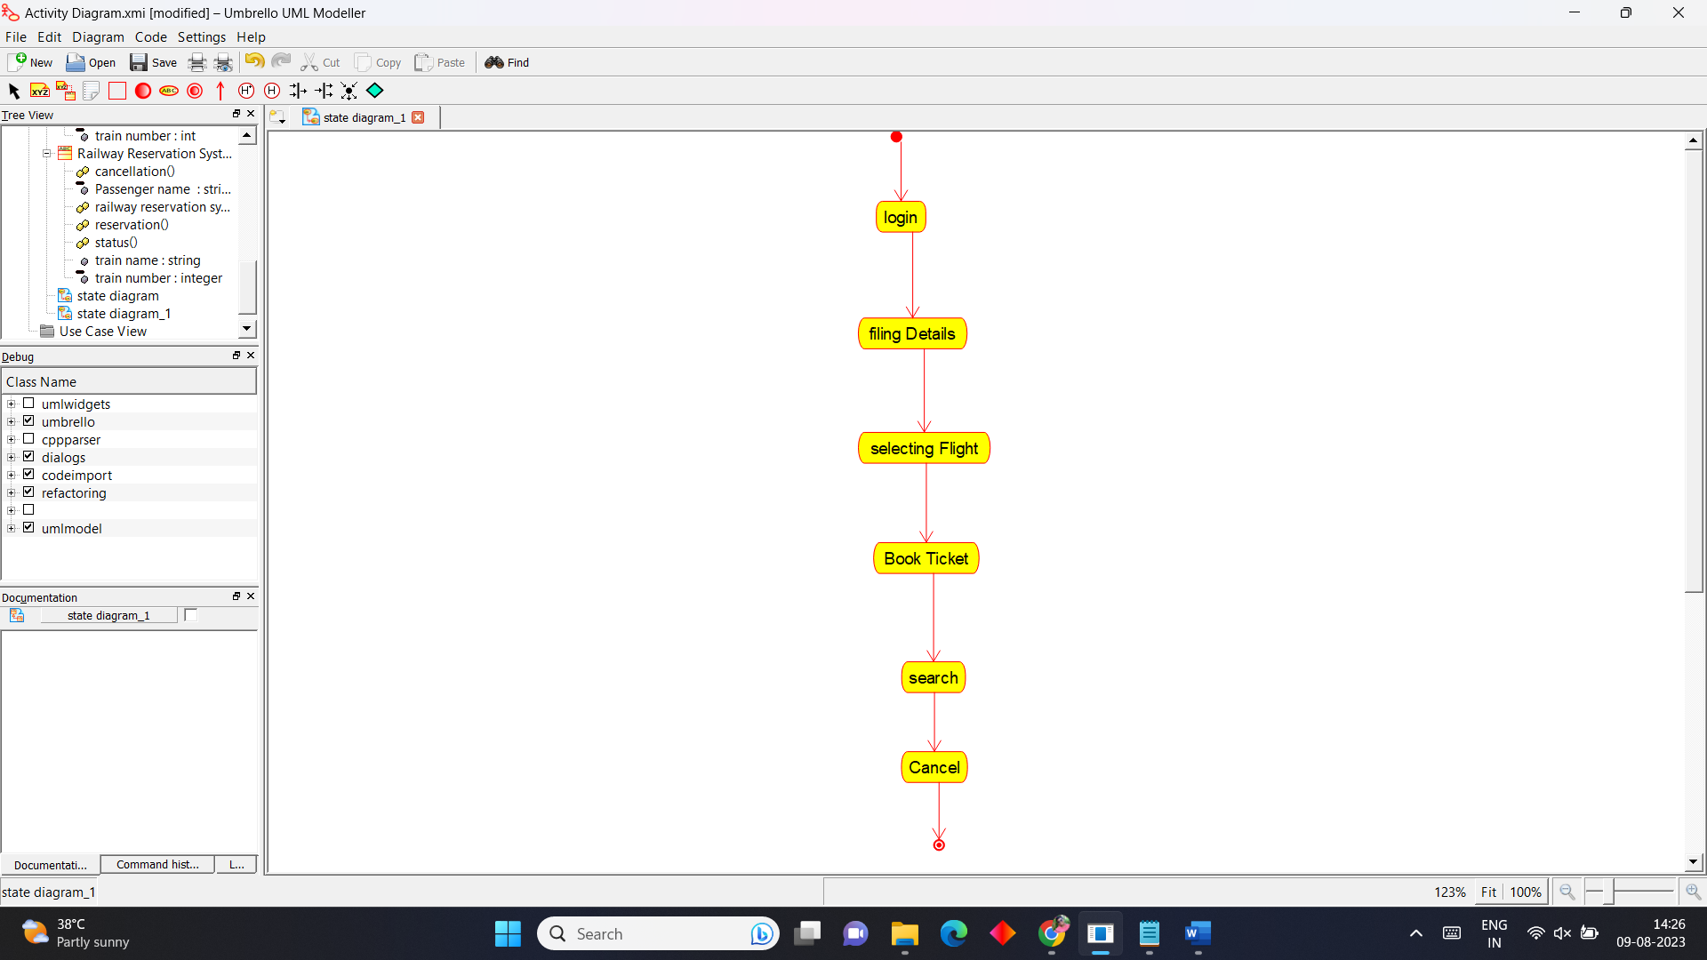

**Sequence Diagram**

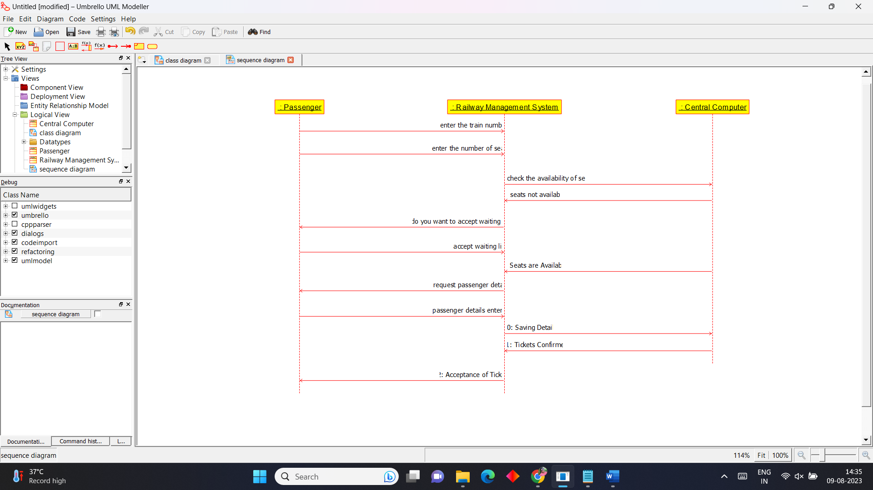

**7.Credit Card Processing System**

**Use Case Diagram**

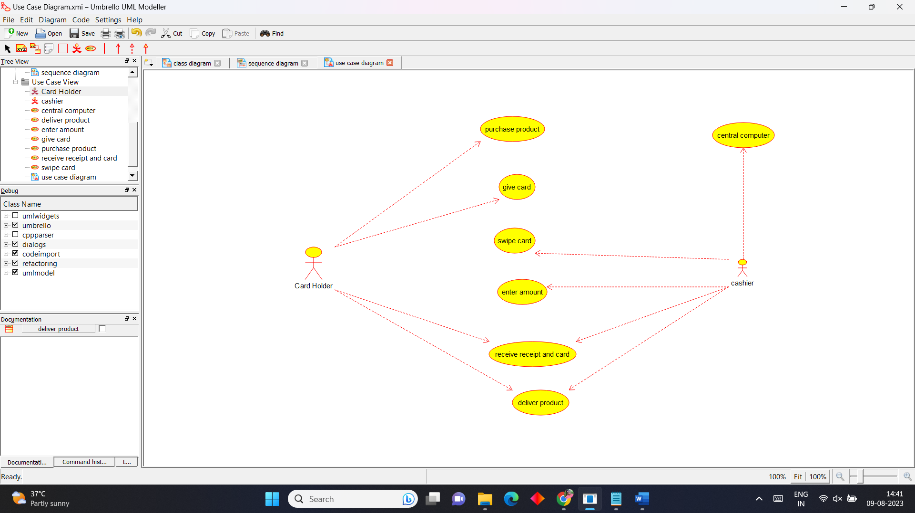

**Class Diagram**

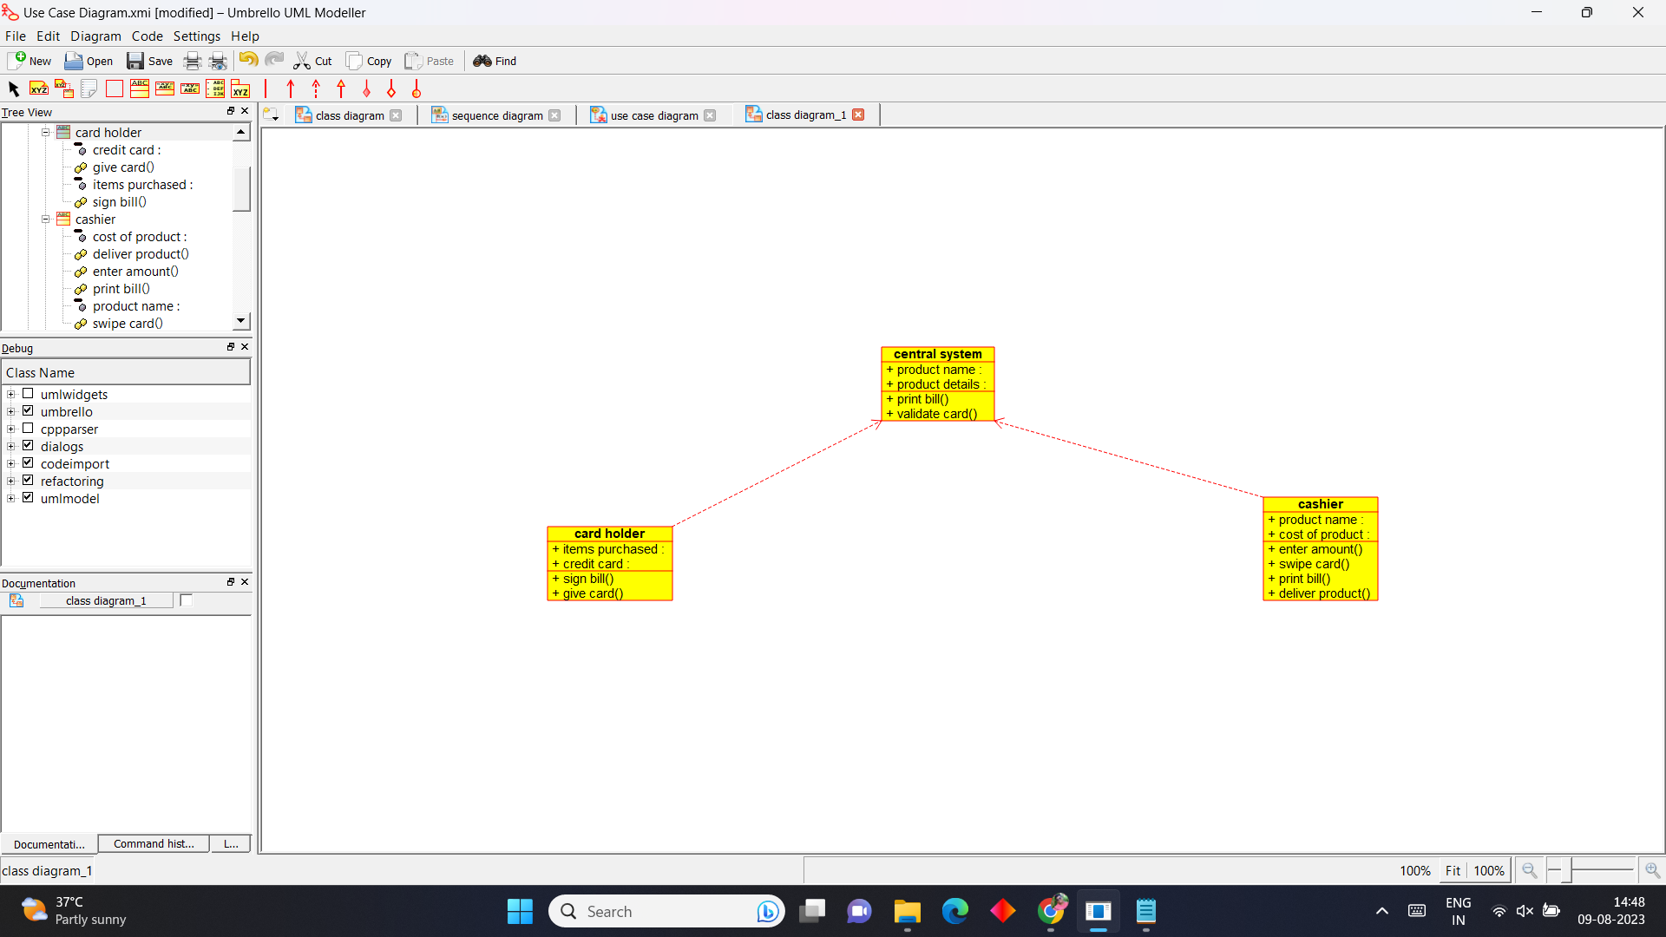

**Activity Diagram**

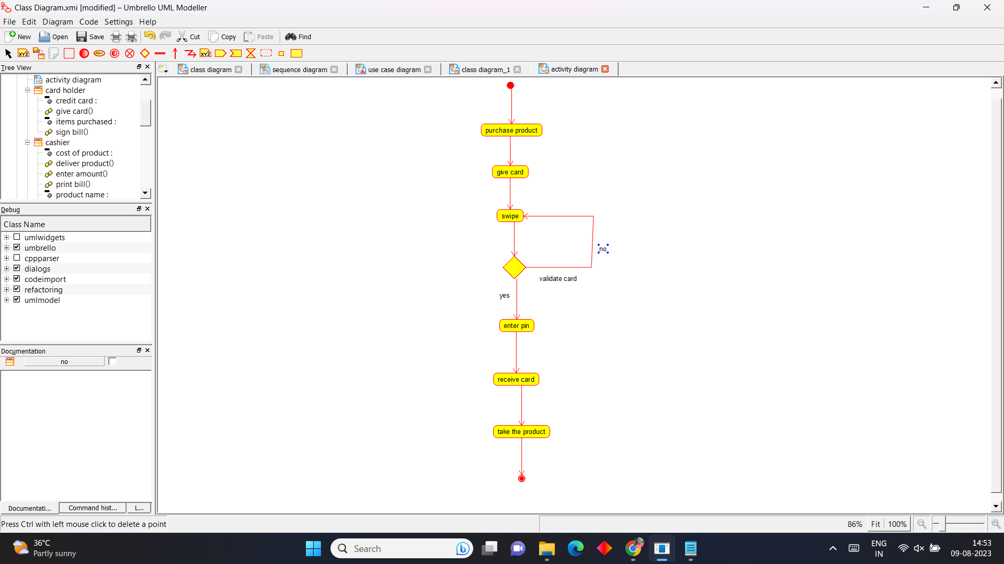

**State Chart Diagram**

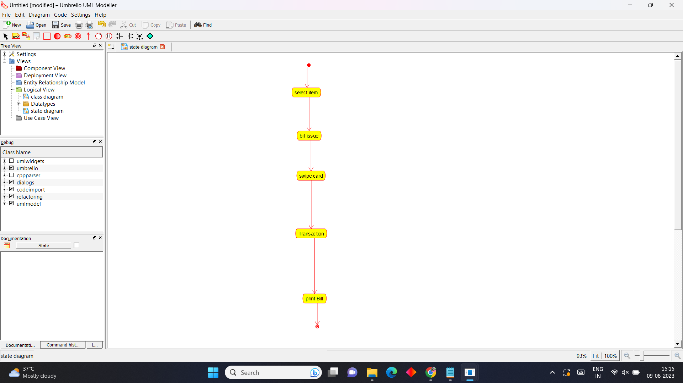

**Sequence Diagram**

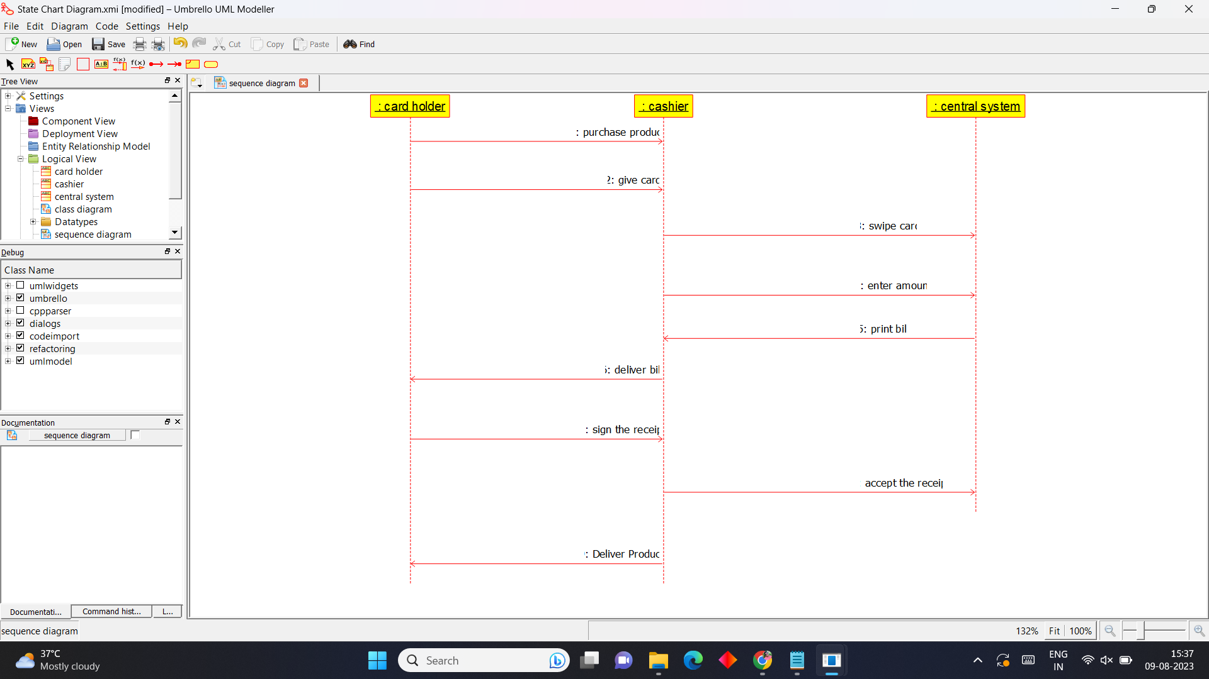

**8. Software Personnel Management System**

**Use Case Diagram**

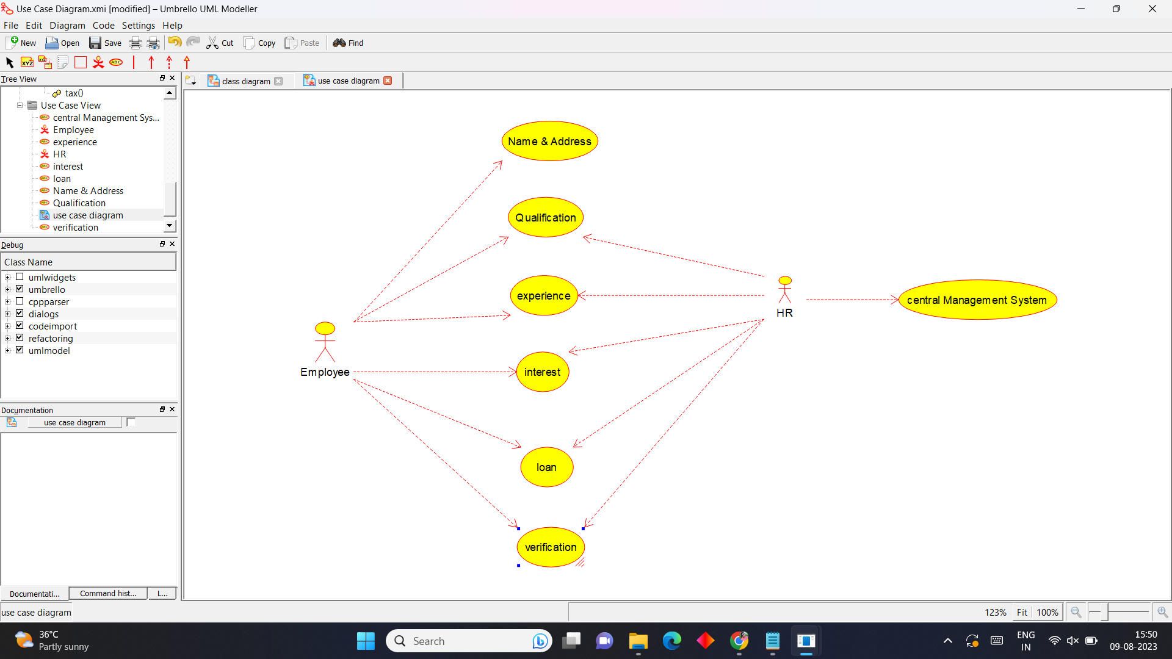

**Class Diagram**

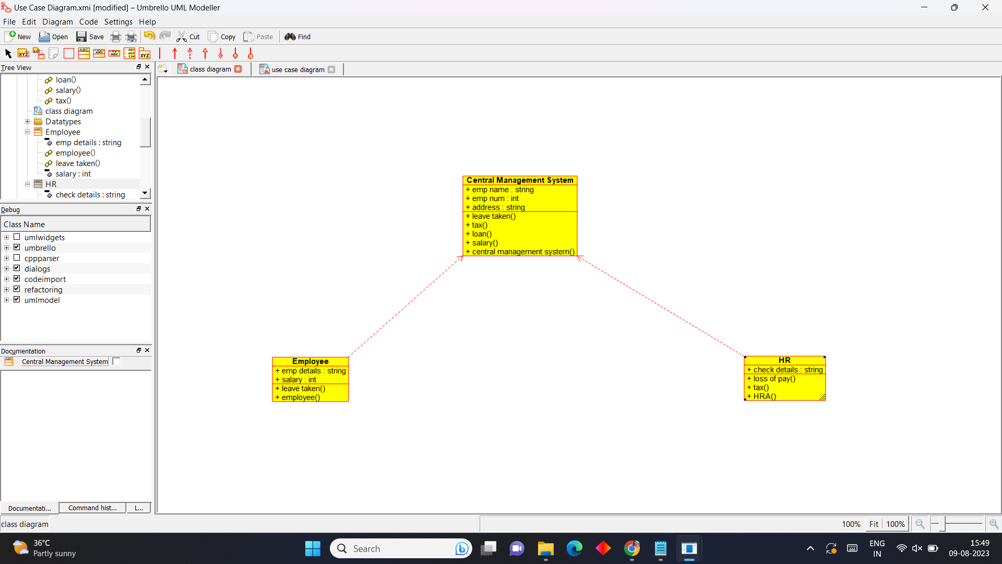

**Activity Diagram**

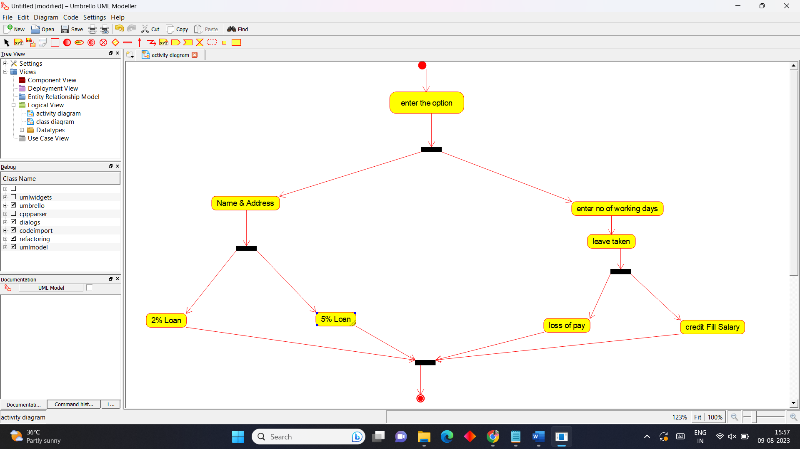

**State Chart Diagram**

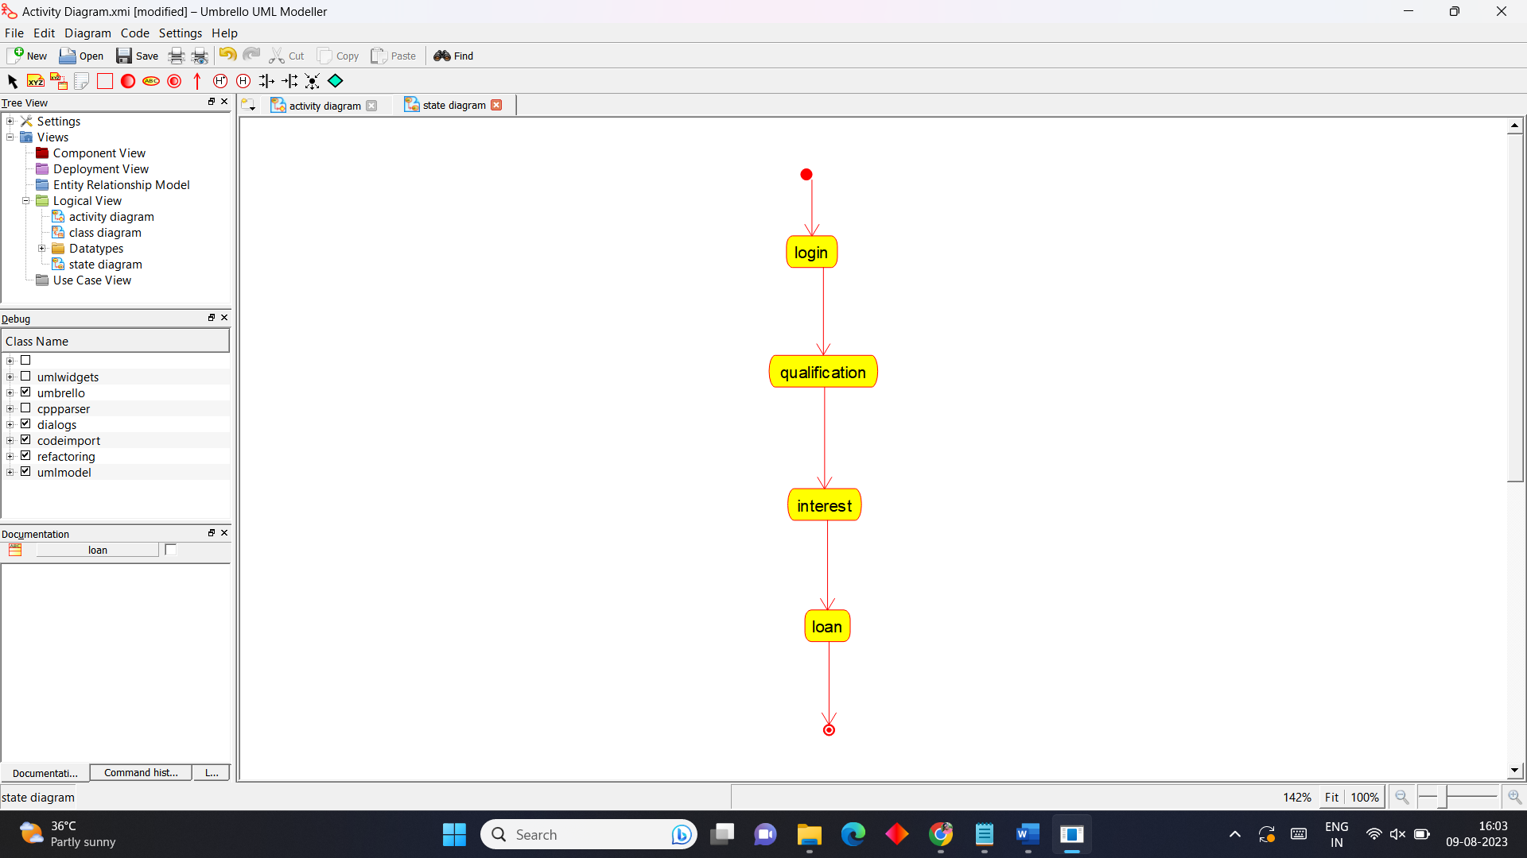

**Sequence Diagram**

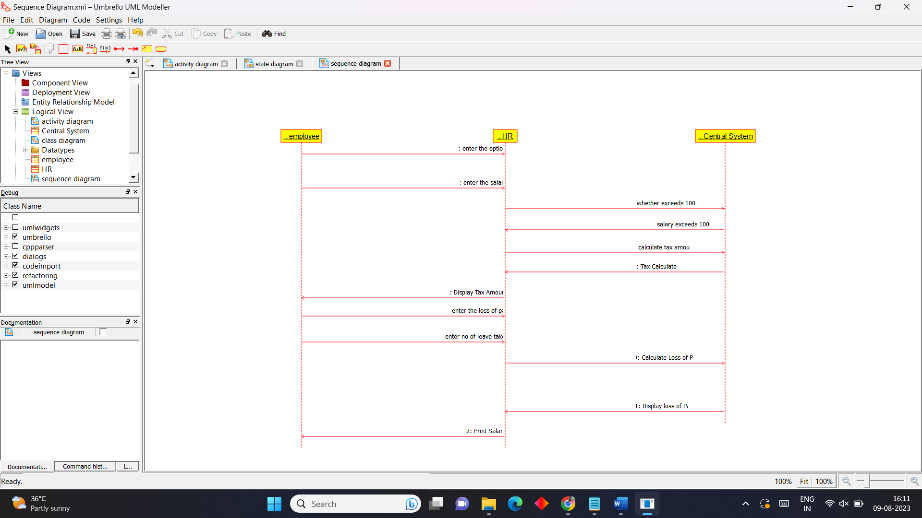

**9.E-Book Management System**

**Use Case Diagram**

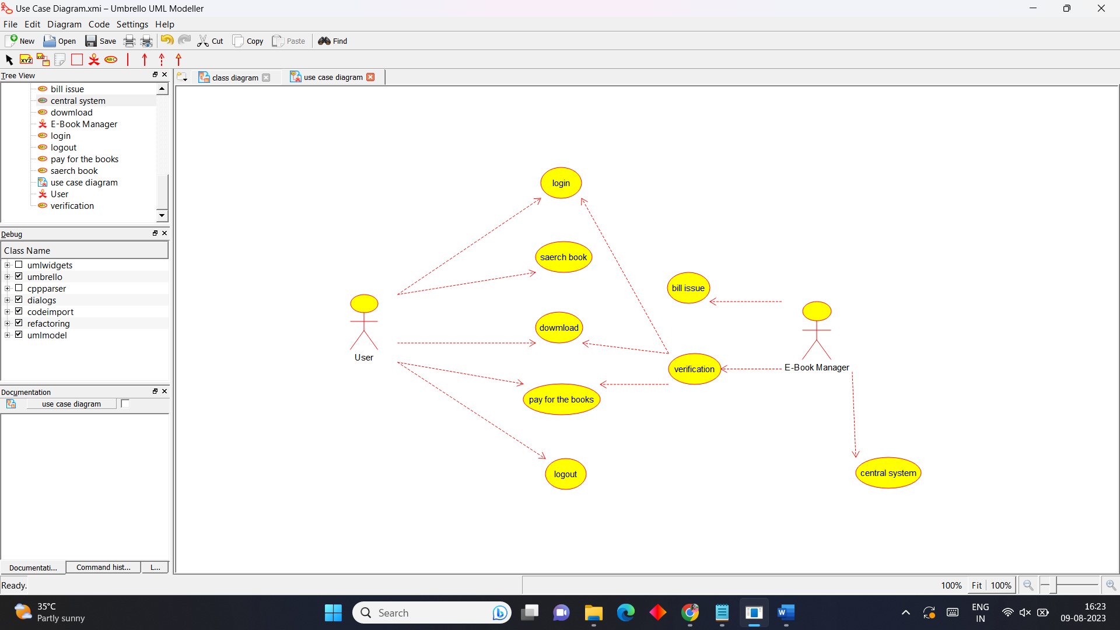

**Class Diagram**



**Activity Diagram**

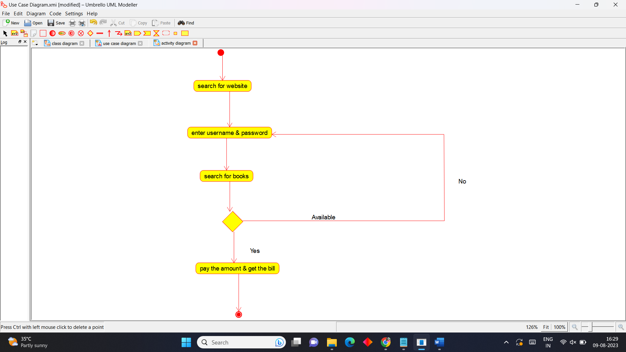

**State Chart Diagram**

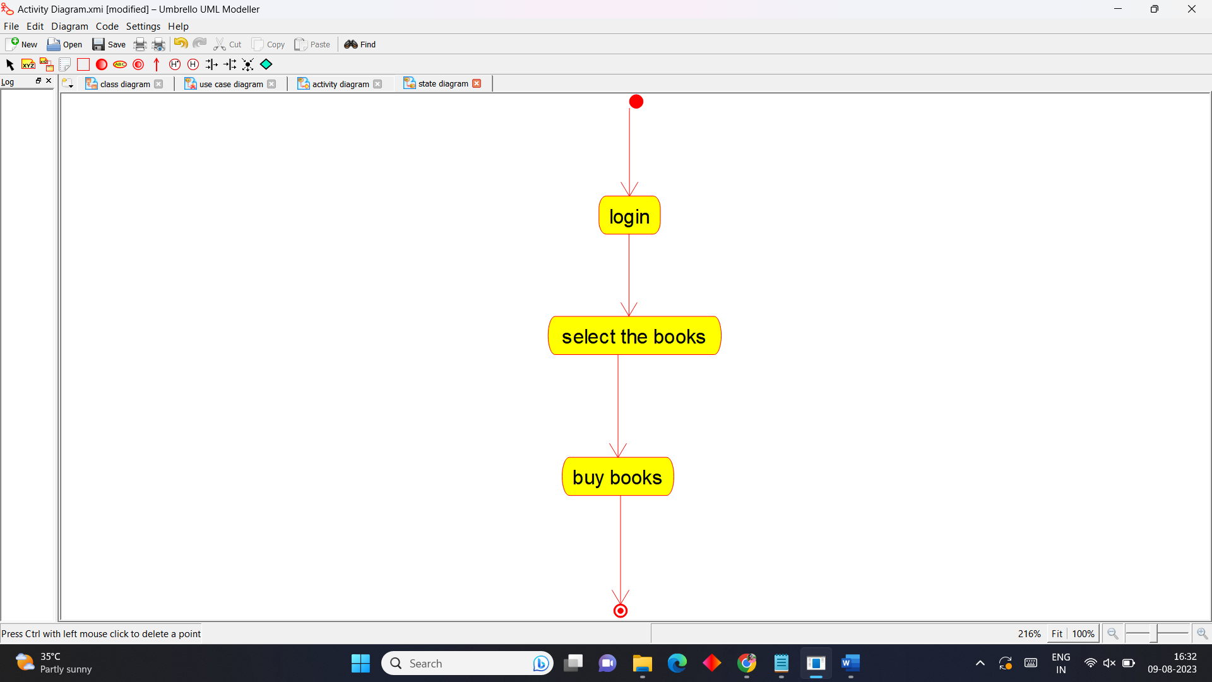

**Sequence Diagram**

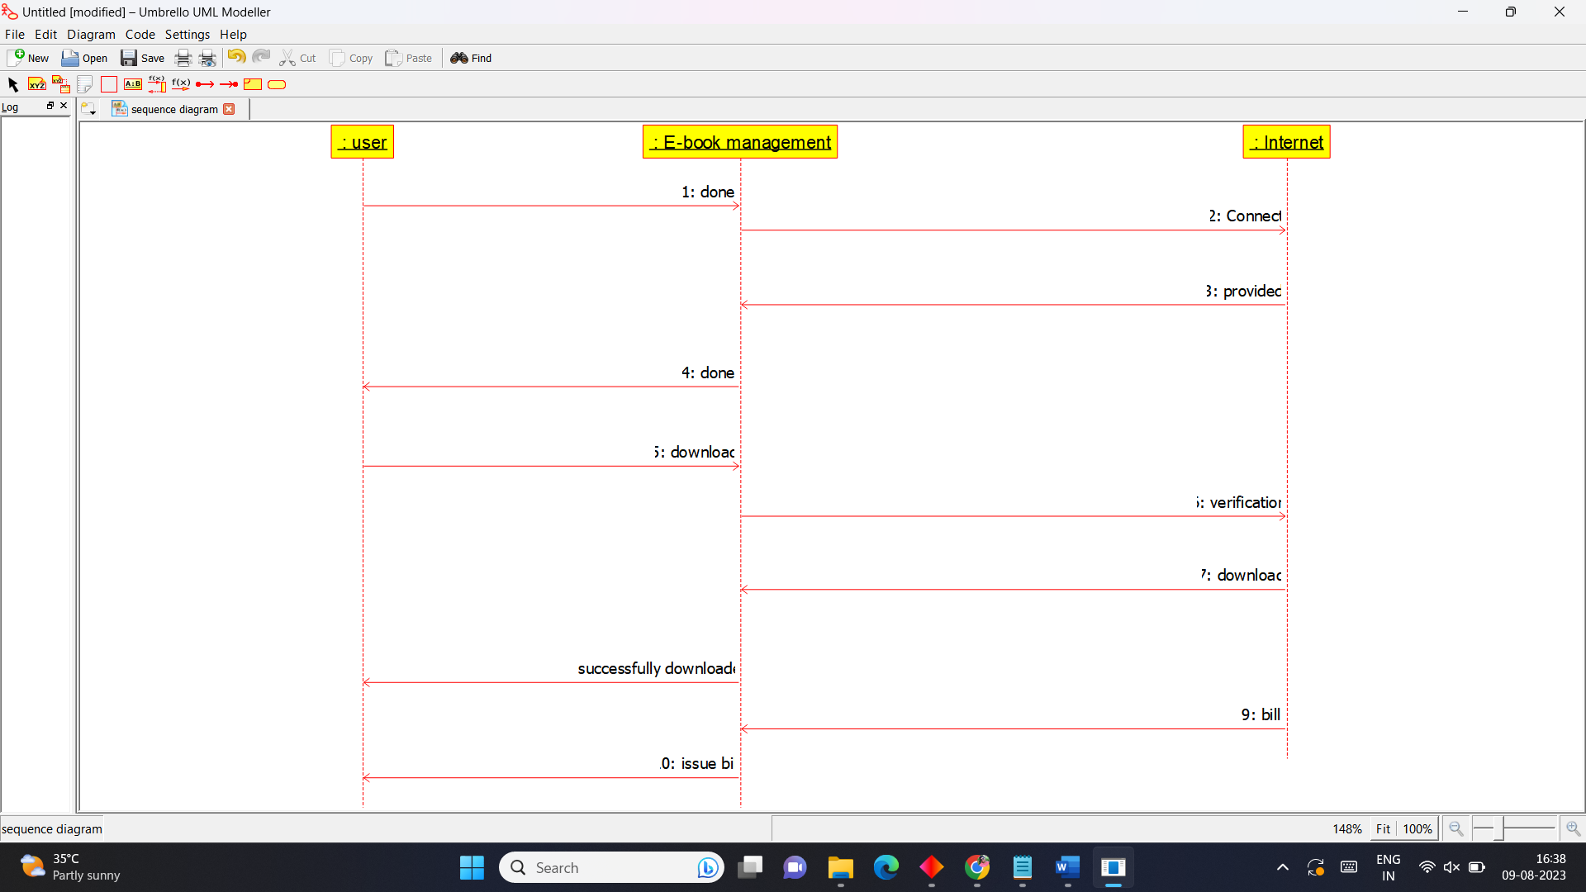

**10.Recruitment System**

**Use Case Diagram**

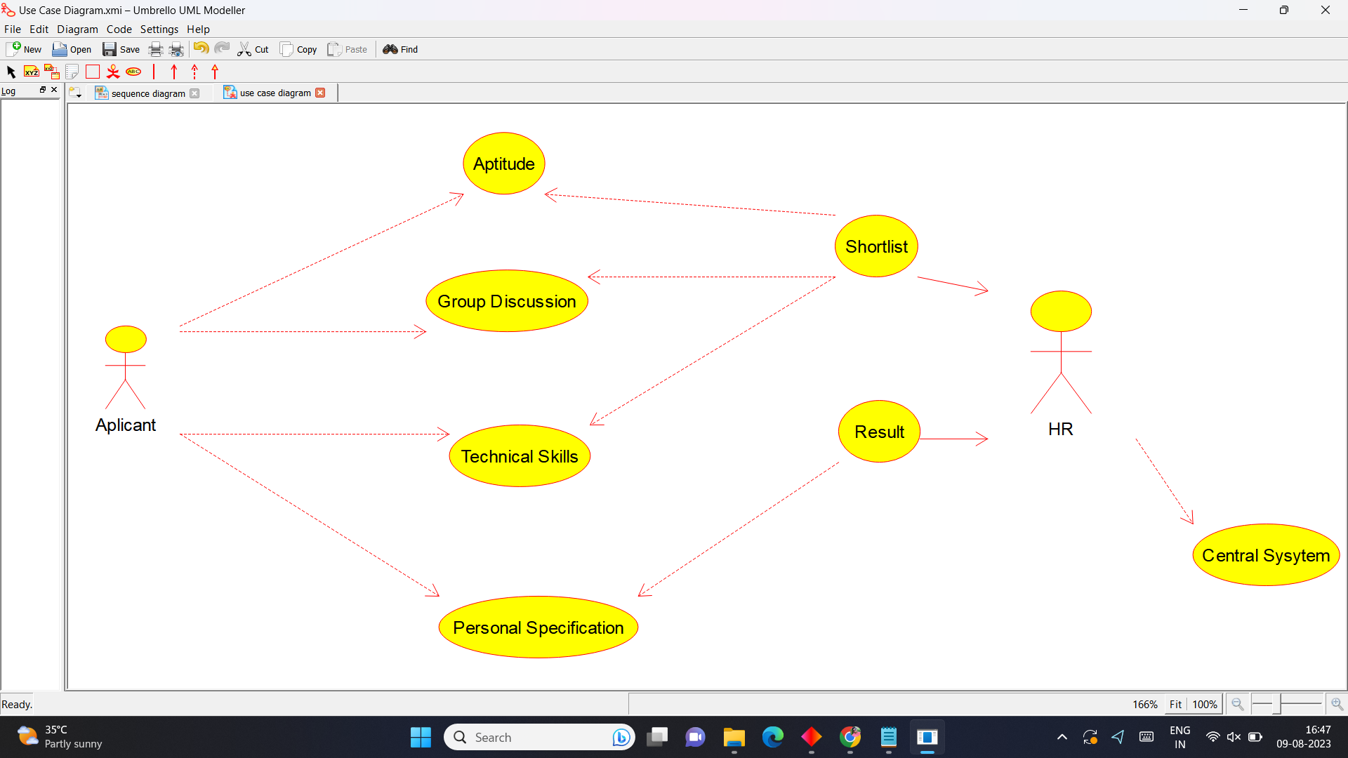

**Class Diagram**

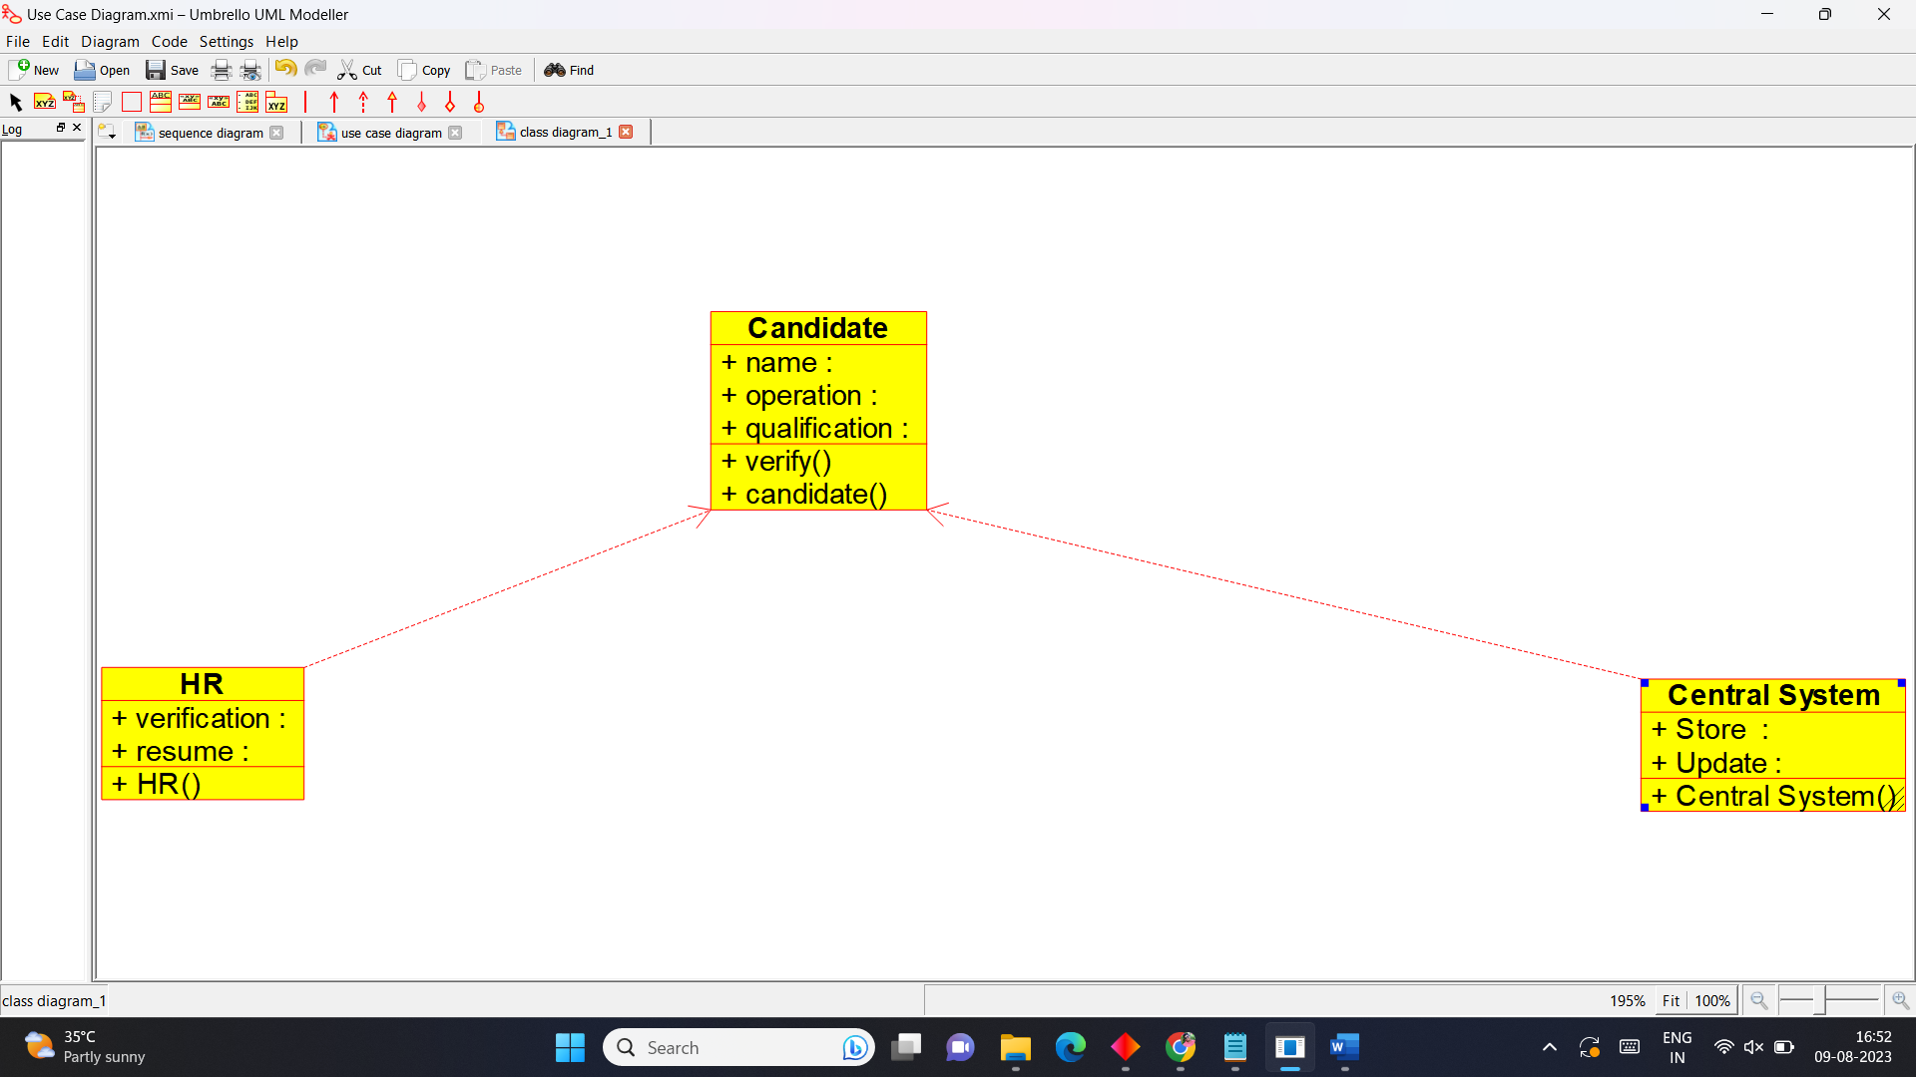

**Activity Diagram**

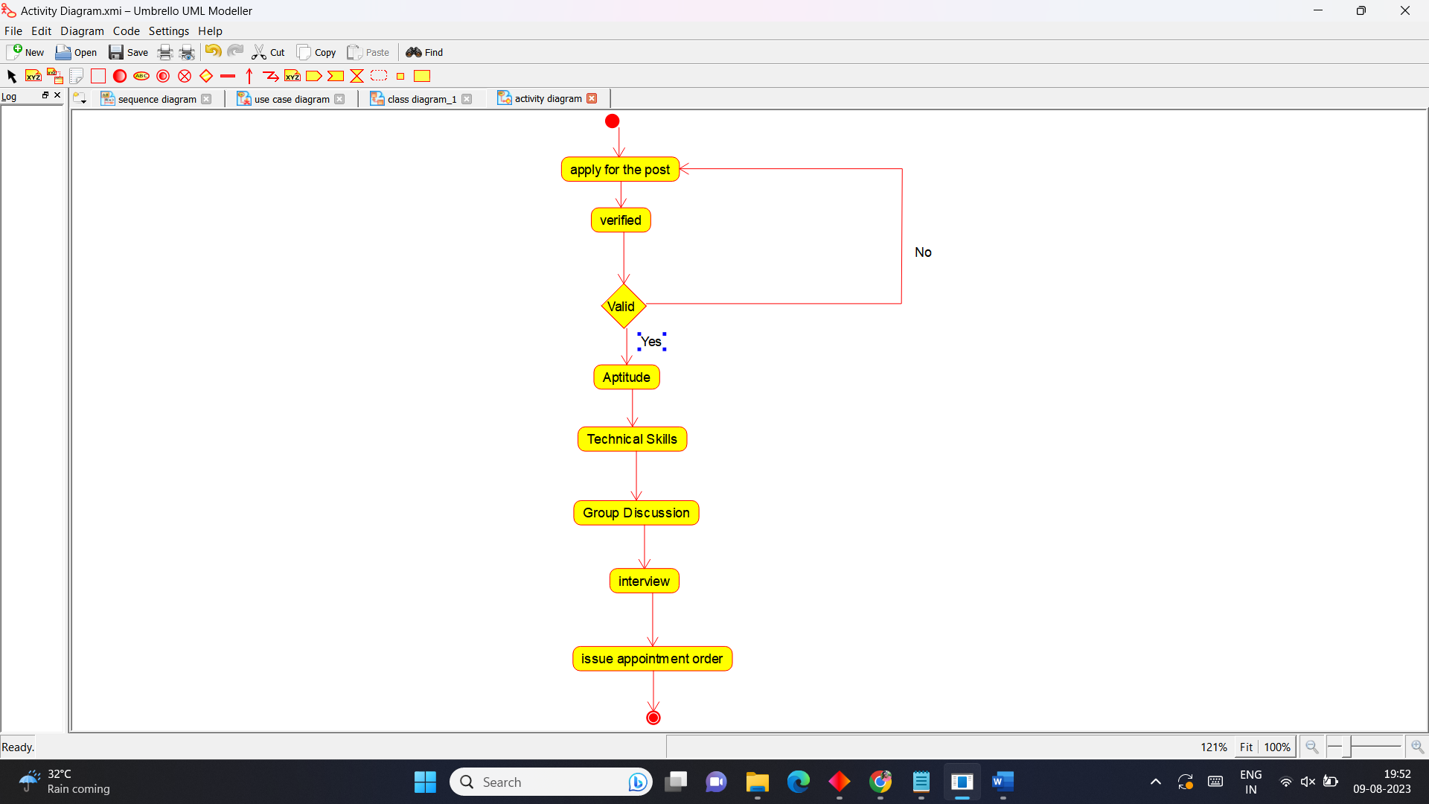

**State Chart Diagram**

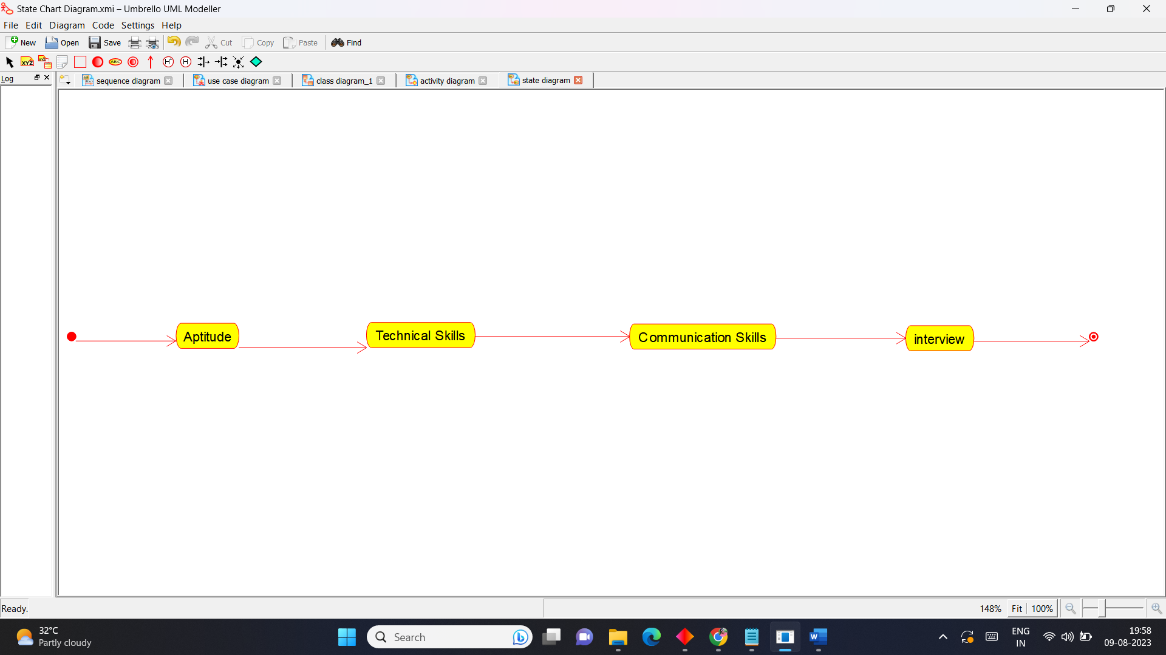

**Sequence Diagram**

